SE-204: Database Management Systems

SQL Practicals

1- Basic SQL SELECT Statements and Restricting and Sorting Data
3-Single-Row Functions
4-Displaying Data from Multiple Tables
5-Aggregating Data Using Group Functions and Subqueries
6-Manipulating Data
7-Creating and Managing Tables
8-Constraints
9- Creating Views
PL/SQL Section
10-Declaring Variables
12-Writing Executable Statements
13-Interacting with the Oracle Server
14-Writing Control Structures

Note: The following software is used: ORACLE.

Tables Used in the Course
EMPLOYEES,
DEPARTMENTS,
JOB_GRADES

Tables Used in the Course
The following main tables are used in this course:
• EMPLOYEES table, which gives details of all the employees
• DEPARTMENTS table, which gives details of all the departments
• JOB_GRADES table, which gives details of salaries for various grades
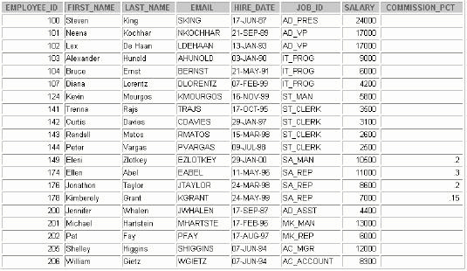
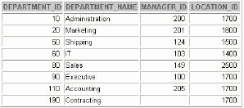
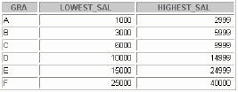

1-Writing Basic SQL SELECT Statements

Objectives
After completing this lesson, you should be able to
do the following:
• List the capabilities of SQL SELECT statements
• Execute a basic SELECT statement
• Differentiate between SQL statements and iSQL*Plus commands

Capabilities of SQL SELECT Statements
Projection Selection Join
A SELECT statement retrieves information from the database. Using a
SELECT statement, you can do the following:
• Projection: You can use the projection capability in SQL to choose the columns in a table that you want returned by your query. You can choose as few or as many co lumns of the table as you require.
• Selection: You can use the selection capability in SQL to choose the rows in a table that you wantreturned by a query. You can use various criteria to restrict the rows that you see.
• Joining: You can use the join capability in SQL to bring together data that is stored in different tables by creating a link between them. You learn more about joins in a later lesson.

Basic SELECTStatement
SELECT *|{[DISTINCT] column | expression [ alias ],...} FROM
table;
•SELECT identifies what columns
• FROM identifies which table
Selecting All Columns
SELECT * FROM departments;

SELECT department_id, department_name, manager_id, location_ id FROM departments;
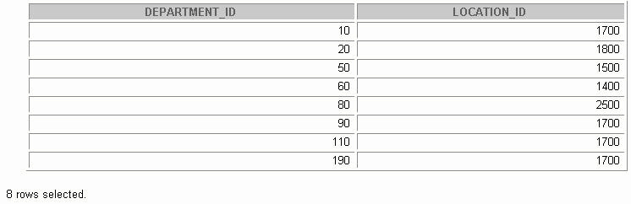
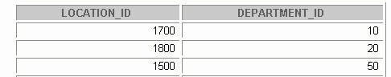

Selecting Specific Columns
SELECT department_id, location_id FROM departments;
Arithmetic Expressions
Create expressions with number and date data by
using arithmetic operators.
Operator Description
+ Add
- Subtract
* Multiply
/ Divide
Using Arithmetic Operators
SELECT last_name, salary, salary + 300 FROM employees;

Operator Precedence
/ *+ _•
Multiplication and division take priority over addition and subtraction.
•Operators of the same priority are evaluated from
left to right.
•Parentheses are used to force prioritized evaluation and to clarify statements.
Operator Precedence
SELECT last_name, salary, 12*salary+100 FROM employees;
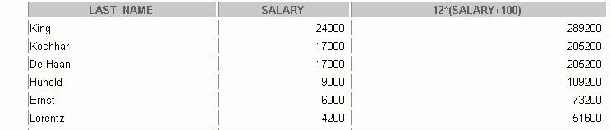
Using Parentheses
SELECT last_name, salary, 12*(salary+100) FROM employees;
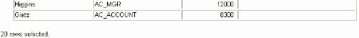

Defining a Null Value
• A null is a value that is unavailable, unassigned,
unknown, or inapplicable.
• A null is not the same as zero or a blank space.
SELECT last_name, job_id, salary, commission_pct
FROM employees;
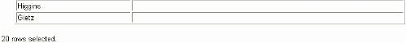
Null Values in Arithmetic Expressions
Arithmetic expressions containing a null value
evaluate to null.
SELECT last_name, 12*salary*commission_pct FROM employees;

Defining a Column Alias
A column alias:
•Renames a column heading
• Is useful with calculations
• Immediately follows the column name: there can
also be the optional AS keyword between the column name and alias
• Requires double quotation marks if it contains
spaces or special characters or is case sensitive
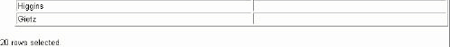
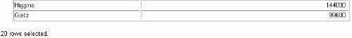
Using Column Aliases
SELECT last_name AS name, commission_pct comm
FROM employees;
SELECT last_name "Name",salary*12 "Annual Salary"
FROM employees;
A concatenation operator:
• Concatenates columns or character strings to
other columns
• Is represented by two vertical bars (||)
• Creates a resultant column that is a character
expression
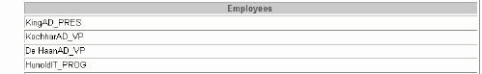
SELECT last_name||job_id AS "Employees" FROM employees;
Using the Concatenation Operator
Literal Character Strings
• A literal value is a character, a number, or a date
included in the SELECT list.
• Date and character literal values must be enclosed
within single quotation marks.
• Each character string is output once for each
row returned.
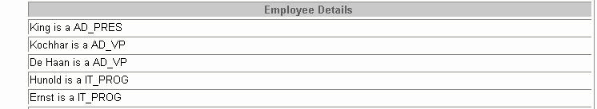
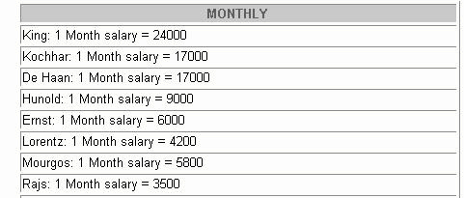
Using Literal Character Strings
SELECT last_name ||' is a '||job_id AS "Employee Details"
FROM employees;
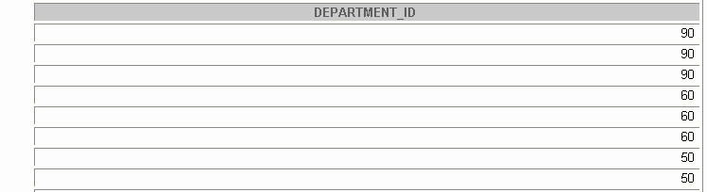
Duplicate Rows
The default display of queries is all rows, including
duplicate rows.
SELECT department_id FROM employees;
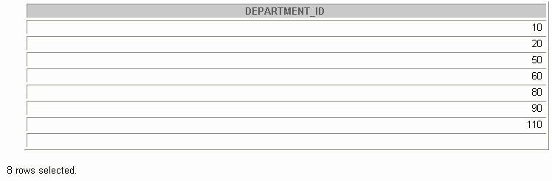
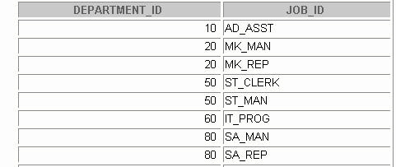
Eliminating Duplicate Rows
Eliminate duplicate rows by using the
DISTINCT keyword in the SELECT clause.
SELECT DISTINCT department_id FROM employees;
SQL and iSQL*Plus Interaction
SQL statements iSQL*Plus Oracle Internet server Browser
Query results iSQL*Plus commands Formatted report Client
SQL and iSQL*Plus SQL is a command language for communication with the Oracle server f rom any tool or application. Oracle SQL contains many extensions.
iSQL*Plus is an Oracle tool that recognizes and submits SQL statements to the Oracle server for execution and contains its own command language.
Features of SQL
• Can be used by a range of users, including those with little or no programming experience
• Is a nonprocedural language
• Reduces the amount of time required for creating and maintaining systems
• Is an English-like language
Features of iSQL*Plus
• Accessed from a browser
• Accepts ad hoc entry of statements
• Provides online editing for modifying SQL statements
• Controls environmental settings
• Formats query results into a basic report
• Accesses local and remote databases
SQL Statements versus iSQL*Plus Commands
SQL iSQL*Plus
• A language
• An environment
• ANSI standard
• Oracle proprietary
• Keyword cannot be
• Keywords can be abbreviated abbreviated
• Statements manipulate
• Commands do not allow data and table definitions manipulation of values in in the database the database
• Runs on a browser
• Centrally loaded, does not have to be implemented on each machine SQL iSQL*Plus statements commands
SQL and iSQL*Plus (continued)

Paper-Based Questions
For questions 2–4, circle either True or False.

Practice 1
1. Initiate an iSQL*Plus session using the user ID and password provided by the instructor.
2.iSQL*Plus commands access the database.
True/False
3. The following SELECT statement executes successfully:
SELECT last_name, job_id, salary AS Sal FROM employees;
True/False
4. The following SELECT statement executes successfully:
SELECT * FROM job_grades;
True/False
5. There are four coding errors in this statement. Can you identif y them?
SELECT employee_id, last_name sal x 12 ANNUAL SALARY
FROM employees;
6. Show the structure of the DEPARTMENTS table. Select all data from the table.
7. Show the structure of the
EMPLOYEES table. Create a query to display the last name, job code, hire
date, and employee number for each employee, with employee number appearing first. Save your SQL statement to a file named lab1_7.sql.
8. Run your query in the file lab1_7.sql.
9. Create a query to display unique job codes from the EMPLOYEES table.
If you have time, complete the following exercises:
10. Copy the statement from lab1_7.sql into the iSQL*Plus Edit window. Name the column headings Emp #,Employee,Job, and Hire Date, respectively. Run your query again.
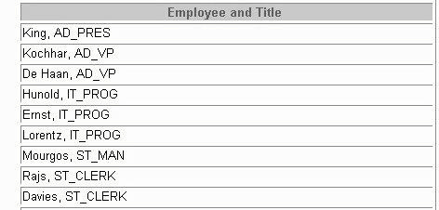
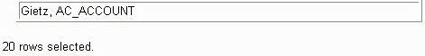
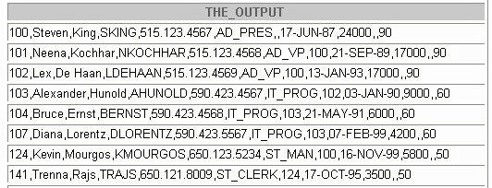
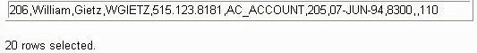
11. Display the last name concatenated with the job ID, separated by a comma and space, and name the column Employee and Title.
If you want an extra challenge, complete the following exercise:
12. Create a query to display all the data from the EMPLOYEES
table. Separate each column by a comma. Name the column THE_OUTPUT.

Restricting and Sorting Data Objectives
After completing this lesson, you should be able to
do the following:
• Limit the rows retrieved by a query
• Sort the rows retrieved by a query

Limiting Rows Using a Selection
EMPLOYEES “retrieve all employees in department 90”
Limiting Rows Using a Selection
Limiting the Rows Selected
• Restrict the rows returned by using the WHERE clause.
SELECT *|{[DISTINCT] column|expression [ alias ],...} FROM table [WHERE condition(s) ];
•The WHERE clause follows the FROM clause.
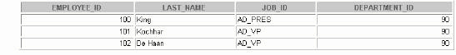
Using theWHERE Clause
SELECT employee_id, last_name, job_id, department_id
FROM employees
WHERE department_id = 90;
Character Strings and Dates
• Character strings and date values are enclosed in
single quotation marks.
• Character values are case sensitive, and date
values are format sensitive.
• The default date format is DD-MON-RR.
SELECT last_name, job_id, department_id FROM employees
WHERE last_name = 'Goyal';

Comparison Conditions
Operator Meaning
= Equal to
> Greater than
>= Greater than or equal to
< Less than
<= Less than or equal to
<> Not equal to

Example
... WHERE hire_date='01-JAN-95'
... WHERE salary>=6000
... WHERE last_name='Smith'
An alias cannot be used in the WHERE clause.
Note:The symbol != and ^= can also represent the not equal to condition.
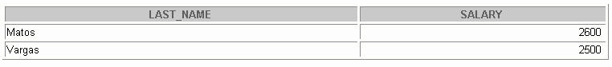
Using Comparison Conditions
SELECT last_name, salary FROM employees
WHERE salary <= 3000;
Using the Comparison Conditions
Other Comparison Conditions
Operator Meaning
BETWEEN Between two values (inclusive)
...AND...
IN(set) Match any of a list of values
LIKE Match a character pattern
IS NULL Is a null value

Using the BETWEEN Condition
Use the BETWEEN condition to display rows based on
a range of values.
SELECT last_name, salary
FROM employees
WHERE salary BETWEEN 2500 AND 3500;
Lower limit Upper limit
The BETWEEN Condition
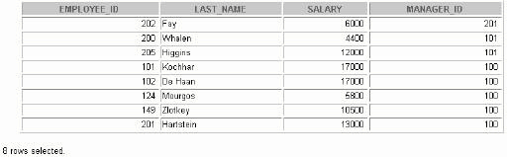
Using the IN Condition
Use the IN membership condition to test for values in
a list.
SELECT employee_id, last_name, salary, manager_id
FROM employees
WHERE manager_id IN (100, 101, 201);

Using the LIKE Condition
•Use the LIKE condition to perform wildcard
searches of valid search string values.
•Search conditions can contain either literal
characters or numbers:
– % denotes zero or many characters.
–_denotes one character.
SELECT first_name FROM employees WHERE first_name LIKE 'S%';
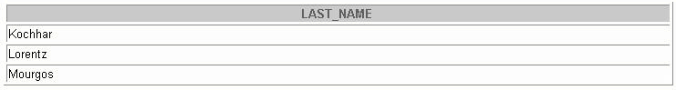
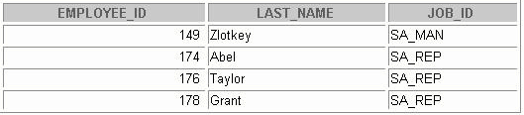
Using the LIKE Condition
• You can combine pattern-matching characters.
SELECT last_name FROM employees
WHERE last_name LIKE '_o%';
• You can use the ESCAPE identifier to search for the
Actual % and _ symbols.
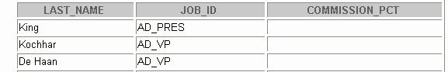
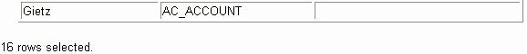
Using theNULLConditions
Test for nulls with the IS NULL operator.
SELECT last_name, manager_id FROM employees
WHERE manager_id IS NULL;
Logical Conditions
Meaning Operator
Returns TRUE if both component
AND conditions are true
OR Returns TRUE
If either component
condition is true
NOT Returns TRUE if the following
condition is false
Using the AND Operator
AND requires both conditions to be true.
SELECT employee_id, last_name, job_id, salary
FROM employees
WHERE salary >=10000
AND job_id LIKE '%MAN%';
Using the OR Operator
OR
requires either condition to be true.
SELECT employee_id, last_name, job_id, salary
FROM employees
WHERE salary >= 10000
OR job_id LIKE '%MAN%';
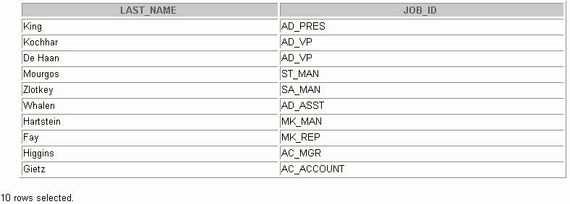
Using the NOT Operator
SELECT last_name, job_id
FROM employees
WHERE job_id NOT IN ('IT_PROG', 'ST_CLERK', 'SA_REP');
Rules of Precedence
Order Evaluated Operator
1 Arithmetic operators
2 Concatenation operator
3 Comparison conditions
4 IS [NOT] NULL , LIKE , [NOT] IN
5 [NOT] BETWEEN
6 NOT logical condition
7 AND logical condition
8 OR logical condition
Override rules of precedence by using parentheses.
SELECT last_name, job_id, salary
FROM employees
WHERE job_id = 'SA_REP'
OR job_id = 'AD_PRES'
AND salary > 15000;

Use parentheses to force priority.
SELECT last_name, job_id, salary
FROM employees
WHERE (job_id = 'SA_REP'
OR job_id = 'AD_PRES')
AND salary > 15000;
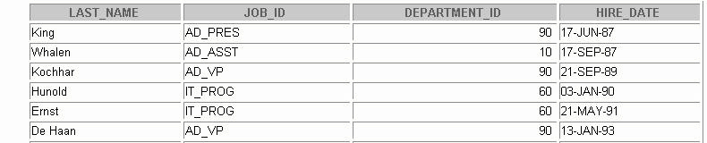
ORDER BY Clause
• Sort rows with the ORDER BY clause
– ASC : ascending order (the default order)
– DESC : descending order
• The ORDER BY clause comes last in the SELECT
statement.
SELECT last_name, job_id, department_id, hire_date FROM employees
ORDER BY hire_date;
Syntax
SELECT expr FROM table [WHERE condition(s) ] [ORDER BY {column,
Expr } [ASC|DESC]];
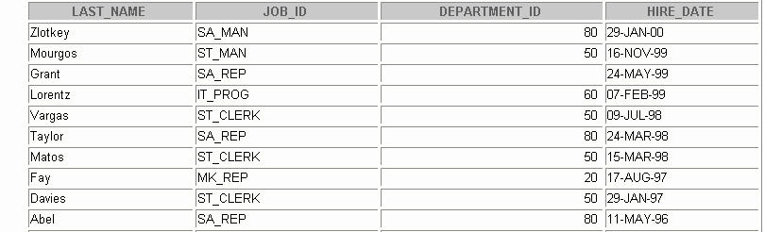
Sorting in Descending Order
SELECT last_name, job_id, department_id, hire_date
FROM employees
ORDER BY hire_date DESC;
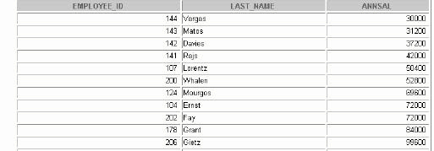
Sorting by Column Alias
SELECT employee_id, last_name, salary*12 annsal
FROM employees
ORDER BY annsal;
Sorting by Column Aliases
You can use a column alias in the ORDER BY clause. The slide example sorts the data by annual salary.
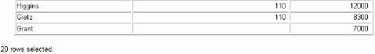
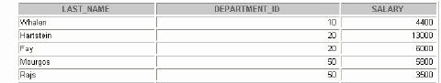
Sorting by Multiple Columns
•The order of ORDER BY list is the order of sort.
SELECT last_name, department_id, salary FROM employees
ORDER BY department_id, salary DESC;
•You can sort by a column that is not in the SELECT list.

Practice 1
1. Create a query to display the last name and salary of employees earning more than $12,000.
Place your SQL statement in a text file named lab2_1.sql . Run your query.
2. Create a query to display the employee last name and department number for employee number 176.
3. Modify lab2_1.sql to display the last name and salary for all employees whose salary is not in the range of $5,000 and $12,000. Place your SQL statement in a text file named lab2_3.sql
4. Display the employee last name, job ID, and start date of employees hired between February 20, 1998, and May 1, 1998. Order the query in ascending order by start date.
5. Display the last name and department number of all employees in departments 20 and 50 in alphabetical order by name.
6. Modify lab2_3.sql to list the last name and salary of employees who earn between $5,000 and $12,000, and are in department 20 or 50. Label the columns Employee and Monthly Salary , respectively. Resave lab2_3.sql as lab2_6.sql . Run the statement in lab2_6.sql .

7. Display the last name and hire date of every employee who was hired in 1994.
8. Display the last name and job title of all employees who do not have a manager.
9. Display the last name, salary, and commission for all employees who earn commissions. Sort data in descending order of salary and commissions.
If you have time, complete the following exercises:
10. Display the last names of all employees where the third letter of the name is an a.
11. Display the last name of all employees who have an a and an e in their last name.
If you want an extra challenge, complete the following exercises:
12. Display the last name, job, and salary for all employees whose job is sales representative or stock clerk and whose salary is not equal to $2,500, $3,500, or $7,000.
13. Modify lab2_6.sql to display the last name, salary, and commission for all employees whose commission amount is 20%. Resave lab2_6.sql as lab2_13.sql . Rerun the statement in lab2_13.sql.

2-Single-Row Functions
Objectives
After completing this lesson, you should be able to
do the following:
• Describe various types of functions available in SQL
• Use character, number, and date functions in SELECT
statements
• Describe the use of conversion functions
SQL Functions
Input Output Function
Function performs action arg 1
arg 2 Result value arg n
Note:
Most of the functions described in this lesson are specific to Oracle Corporation’s version of SQL.
Two Types of SQL Functions
Functions
Single-row functions

Single-Row Functions
Single row functions:
•Manipulate data items
•Accept arguments and return one value
•Act on each row returned
•Return one result per row
•May modify the data type
•Can be nested
•Accept arguments which can be a column or an
expression
function_name[(arg1, arg2,...)]
Single-Row Functions
Single-Row Functions
Character
General
Number
Single-row
functions
Conversion
Date

Character Functions
Character functions
Case-manipulation functions
Character-manipulation functions
LOWER
CONCAT
UPPER
SUBSTR
INITCAP
LENGTH
INSTR
LPAD | RPAD
TRIM
REPLACE
Note: The functions discussed in this lesson are only some of the available functions.
Case Manipulation Functions
These functions convert case for character strings.
Function Result
LOWER('SQL Course') sql course
UPPER('SQL Course') SQL COURSE
INITCAP('SQL Course') Sql Course
Using Case Manipulation Functions
Display the employee number, name, and department
number for employee Higgins:
SELECT employee_id, last_name, department_id
FROM employees
WHERE last_name = 'higgins';
no rows selected
SELECT employee_id, last_name, department_id
FROM employees
WHERE LOWER(last_name) = 'higgins';
Character-Manipulation Functions
These functions manipulate character strings:
Function Result
CONCAT('Hello', 'World') HelloWorld
SUBSTR('HelloWorld',1,5) Hello
LENGTH('HelloWorld') 10
INSTR('HelloWorld', 'W') 6
LPAD(salary,10,'*') *****24000
RPAD(salary, 10, '*') 24000*****
TRIM('H' FROM 'HelloWorld') elloWorld
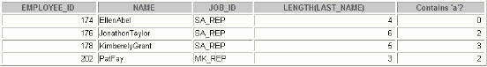
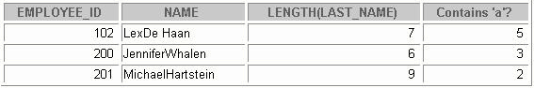
Using the Character-Manipulation
Functions
SELECT employee_id, CONCAT(first_name, last_name) NAME, job_id,
LENGTH (last_name), INSTR(last_name, 'a') "Contains 'a'?"
FROM employees
WHERE SUBSTR(job_id, 4) = 'REP';

Number Functions
• ROUND : Rounds value to specified decimal
ROUND(45.926, 2) 45.93
• TRUNC : Truncates value to specified decimal
TRUNC(45.926, 2) 45.92
• MOD : Returns remainder of division
MOD(1600, 300) 100
Using the ROUND Function
SELECT ROUND(45.923,2), ROUND(45.923,0),ROUND(45.923,-1)
FROM DUAL;
DUAL is a dummy table you can use to view results
from functions and calculations.

Using the TRUNC Function
SELECT TRUNC(45.923,2), TRUNC(45.923), TRUNC(45.923,-2) FROM DUAL;
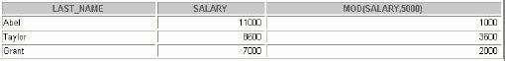
Using the MOD Function
Calculate the remainder of a salary after it is divided
by 5000 for all employees whose job title is sales
representative.
SELECT last_name, salary, MOD(salary, 5000)
FROM employees
WHERE job_id = 'SA_REP';
Working with Dates
• Oracle database stores dates in an internal
numeric format: century, year, month, day, hours,
minutes, seconds.
• The default date display format is DD-MON-RR.
– Allows you to store 21st century dates in the 20th
century by specifying only the last two digits of the
year.
– Allowa you to store 20th century dates in the 21st
century in the same way.
SELECT last_name, hire_date FROM employees
WHERE last_name like 'G%';

Working with Dates
SYSDATE is a function that returns:
•Date
•Time

Example Display the current date using the DUAL table.
SELECT SYSDATE FROM DUAL;

Arithmetic with Dates
•Add or subtract a number to or from a date for a resultant date value.
•Subtract two dates to find the number of days between those dates.
•Add hours to a date by dividing the number of
hours by 24.
Operation Result Description
date + number Date Adds a number of days to a date
date - number Date Subtracts a number of days from a date
date - date Number of days Subtracts one date from another
date + number/24 Date Adds a number of hours to a date
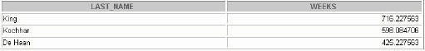
Using Arithmetic Operators with Dates
SELECT last_name, (SYSDATE-hire_date)/7 AS WEEKS
FROM employees
WHERE department_id = 90;

Note:SYSDATE is a SQL function that returns the current date and time. Your results may differ from the example. If a more current date is subtracted from an older date, the difference is a negative number.

Date Functions
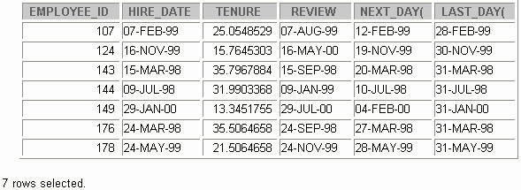
Using Date Functions
•MONTHS_BETWEEN ('01-SEP-95','11-JAN-94')
19.6774194
•ADD_MONTHS ('11-JAN-94',6) '11-JUL-94'
•NEXT_DAY ('01-SEP-95','FRIDAY') '08-SEP-95'
• LAST_DAY('01-FEB-95') '28-FEB-95'
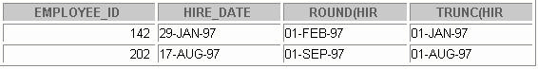
Using Date Functions
Assume SYSDATE = '25-JUL-95':
• ROUND(SYSDATE,'MONTH') 01-AUG-95
• ROUND(SYSDATE ,'YEAR') 01-JAN-96
• TRUNC(SYSDATE ,'MONTH') 01-JUL-95
• TRUNC(SYSDATE ,'YEAR') 01-JAN-95
Example
Compare the hire dates for all employees who started in 1997. Display the employee number, hire date, and month started using the ROUND and TRUNC functions.
SELECT employee_id, hire_date, ROUND(hire_date, 'MONTH'), TRUNC(hire_date, 'MONTH') FROM employees WHERE hire_date LIKE '%97';
Practice 3, Part 1
This practice is designed to give you a variety of exercises using different functions available for character,number, and date data types.
Complete questions 1 through 5 of Practice 3, found at the end of this lesson.

Conversion Functions
Data-type conversion
Implicit data-type conversion

Explicit data-type conversion
Note: Although implicit data-type conversion is available, it is recommended that you do explicit data type conversion to ensure the reliability of your SQL statements.

Implicit Data-Type Conversion
For assignments, the Oracle server can automatically
convert the following:
From To
VARCHAR2 or CHAR NUMBER
VARCHAR2 or CHAR DATE
NUMBER VARCHAR2
DATE VARCHAR2
VARCHAR2 or CHAR DATE
Note: CHAR to NUMBER conversions succeed only if the character string represents a valid number.

Explicit Data-Type Conversion
TO_NUMBER
TO_DATE
NUMBER
DATE
CHARACTER
TO_CHAR
TO_CHAR
Function Purpose
TO_CHAR( number | date ,[ fmt ], Converts a number or date value to a
VARCHAR2 [nlsparams ]) character string with format model fmt.
TO_NUMBER( char,[fmt], Converts a character string containing digits to a
[nlsparams] ) number in the format specified by the optional format model
Fmt . The nlsparams parameter has the same purpose in this function as in the TO_CHAR function for number conversion.
TO_DATE(char ,[ fmt ],[ nlsparams ]) Converts a character string representing a date to a date value according to the fmt specified. If fmt is omitted, the format is DD-MON-YY.The nlsparams parameter has the same purpose in this function as in the TO_CHAR function for date conversion.
Note: The list of functions mentioned in this lesson includes only some of the available conversion functions.
Using the TO_CHAR
Function with Dates
TO_CHAR(date, ' format_model ')
The format model:
•Must be enclosed in single quotation marks and is case
sensitive
•Can include any valid date format element
•Has an fm element to remove padded blanks or
suppress leading zeros
• Is separated from the date value by a comma
SELECT employee_id, TO_CHAR(hire_date, 'MM/YY') Month_Hired
FROM employees
WHERE last_name = 'Higgins';

Elements of the Date Format Model
YYYY Full year in numbers
YEAR Year spelled out
MM Two-digit value for month
MONTH Full name of the month
MON Three-letter abbreviation of the
Month Three-letter abbreviation of the
DY day of the week
DAY Full name of the day of the week
DD Numeric day of the month

Elements of the Date Format Model
• Time elements format the time portion of the date.
HH24:MI:SS AM 15:45:32 PM
• Add character strings by enclosing them in double
quotation marks.
DD "of" MONTH 12 of OCTOBER
• Number suffixes spell out numbers.
ddspth fourteenth
Using the TO_CHAR Function with Dates
SELECT last_name, TO_CHAR(hire_date, 'fmDD Month YYYY') HIREDATE FROM employees;
SELECT last_name, TO_CHAR(hire_date, 'fmDdspth "of" Month YYYY fmHH:MI:SS AM') HIREDATE FROM employees;
Notice that the month follows the format model specified: in oth er words, the first letter is capitalized and the rest are lowercase.
Using the TO_CHAR
Function with Numbers
TO_CHAR( number, ' format_model ')
These are some of the format elements you can use
with the TO_CHAR function to display a number value
as a character:9 Represents a number 0
Forces a zero to be displayed $ Places a floating dollar sign
L Uses the floating local currency symbol. Prints a decimal point, Prints a thousand indicator
Element Description Example Result
9 Numeric position (number of 9s determine display 999999 1234 width)
0 Display leading zeros 099999 001234
$ Floating dollar sign $999999 $1234
L Floating local currency symbol L999999 FF1234
. Decimal point in position specified 999999.99 1234.00
, Comma in position specified 999,999 1,234
MI Minus signs to right (negative values) 999999MI 1234-
PR Parenthesize negative numbers 999999PR <1234>
EEEE Scientific notation (format must specify four Es) 99.999EEEE 1.234E+03
V Multiply by 10 n times ( n = number of 9s after V) 9999V99 123400 B Display zero values as blank, not 0 B9999.99 1234.00
Using the TO_CHAR
Function with Numbers
SELECT TO_CHAR(salary, '$99,999.00') SALARY
FROM employees
WHERE last_name = 'Ernst';

Using the TO_NUMBER
And TO_DATE Functions
•Convert a character string to a number format
using the TO_NUMBER
function: TO_NUMBER( char [,'format_model'])
•Convert a character string to a date format using the
TO_DATE function:
TO_DATE( char [, 'format_model'])
•These functions have an fx modifier. This modifier specifies the exact matching for the character
argument and date format model of a TO_DATE function.
Example
Display the names and hire dates of all the employees who joined on May 24, 1999. Because the fx modifier is used, an exact match is required and the spaces afte r the word “May” are not recognized.
SELECT last_name, hire_date FROM employees
WHERE hire_date = TO_DATE('May 24, 1999', 'fxMonth DD, YYYY')

Example of RR Date Format
To find employees hired prior to 1990, use the
RR format, which produces the same results whether the
command is run in 1999 or now:
SELECT last_name, TO_CHAR(hire_date, 'DD-Mon-YYYY')
FROM employees
WHERE hire_date < TO_DATE('01-Jan-90', 'DD-Mon-RR');
SELECT last_name, TO_CHAR(hire_date, 'DD -Mon-yyyy')
FROM employees
WHERE TO_DATE(hire_date, 'DD-Mon-yy') < '01-Jan-1990';
no rows selected

Nesting Functions
• Single-row functions can be nested to any level.
• Nested functions are evaluated from deepest level
to the least deep level.
F3(F2(F1(col,arg1),arg2),arg3)
Step 1 = Result 1
Step 2 = Result 2
Step 3 = Result 3
Nesting Functions
Single-row functions can be nested to any depth. Nested functions are evaluated from the innermost level to the outermost level. Some examples follow to show you the flexibility of these functions.

Nesting Functions
SELECT last_name,
NVL(TO_CHAR(manager_id), 'No Manager')
FROM employees
WHERE manager_id IS NULL;
Example
Display the date of the next Friday that is six months from the hire date. The resulting date should appear as Friday, August 13th, 1999. Order the results by hire date.
SELECT TO_CHAR(NEXT_DAY(ADD_MONTHS
(hire_date, 6), 'FRIDAY'),
'fmDay, Month DDth, YYYY')
"Next 6 Month Review"
FROM employees
ORDER BY hire_date;

General Functions
These functions work with any data type and pertain
to using null value.
• NVL (expr1, expr2)
• NVL2 (expr1, expr2, expr3)
• NULLIF (expr1, expr2)
•COALESCE (expr1, expr2, ..., exprn)
Function Description
NVL Converts a null value to an actual value
NVL2 If expr1 is not null, NVL2 returns expr2.
NULLIF If expr1 is null, NVL2 returns. The argument can have any data type. expr3 expr1
COALESCE Compares two expressions and returns null if they are equal, or the first expression if they are not equal Returns the first non-null expression in the expression list
NVL Function
• Converts a null to an actual value
• Data types that can be used are date, character,
and number.
• Data types must match:
– NVL(commission_pct,0)
– NVL(hire_date,'01-JAN-97')
– NVL(job_id,'No Job Yet')
NVL Conversions for Various Data Types
Data Type Conversion Example
NUMBER NVL( number_column ,9)
DATE NVL( date_column, '01-JAN-95')
CHAR or VARCHAR2 NVL( character_column , 'Unavailable')
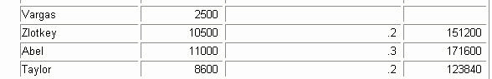

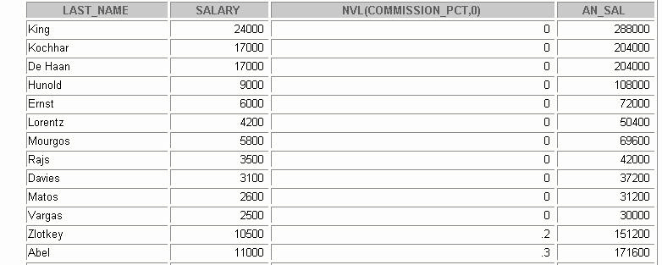
Using the NVL Function
SELECT last_name, salary, NVL(commission_pct, 0),
(salary*12) + (salary*12*NVL(commission_pct, 0)) AN_SAL
FROM employees;
The NVL Function
To calculate the annual compensation of all employees, you need to multiply the monthly salary by 12 and then add the commission percentage to it.
SELECT last_name, salary, commission_pct, (salary*12) + (salary*12*commission_pct) AN_SAL FROM employees;
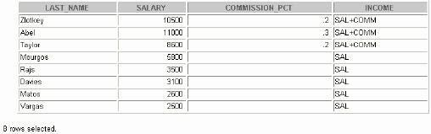
Using the NVL2 Function
SELECT last_name, salary, commission_pct,
NVL2(commission_pct,'SAL+COMM', 'SAL') income
FROM employees WHERE department_id IN (50, 80);
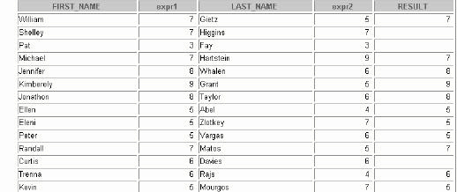
Using the NULLIF Function
SELECT first_name, LENGTH(first_name) "expr1",
last_name, LENGTH(last_name) "expr2",
NULLIF(LENGTH(first_name), LENGTH(last_name)) result
FROM employees;
Note:
The NULLIF function is logically equivalent to the following CASE
expression. The CASE expression is discussed in a subsequent page:
CASE WHEN expr1 = expr 2 THEN NULL ELSE expr1 END

Practice 2, Part 1 (continued)
5. Write a query that displays the employee’s last names with the first letter capitalized and all other letters lowercase and the length of the names, for all employees whose name starts with J , A , or M . Give each column an appropriate label. Sort the results by the employees’ last names.

Practice 2, Part 2
6. For each employee, display the employee’s last name, and calculate the number of months between today and the date the employee was hired. Label the column MONTHS_WORKED . Order your results by the number of months employed. Round the number of months up to the closest whole number.
Note:
Your results will differ.

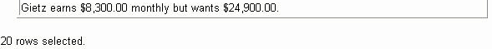

Practice 3, Part 2 (continued)
7. Write a query that produces the following for each employee:
< employee last name> earns <salary> monthly but wants <3 times salary >. Label the column Dream Salaries . If you have time, complete the following exercises:
8. Create a query to display the last name and salary for all employees. Format the salary to be 15 characters long, left-padded with $. Label the column SALARY .
9. Display each employee’s last name, hire date, and salary review date, which is the first Monday after six months of service. Label the column
REVIEW. Format the dates to appear similar to “Monday, the Thirty-First of July, 2000.”
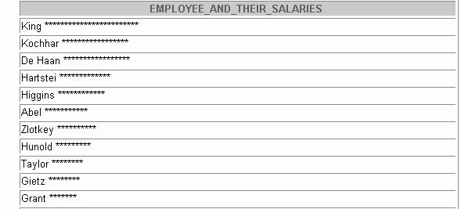
10. Display the last name, hire date, and day of the week on which the employee started. Label the column DAY . Order the results by the day of the week starting with Monday.
If you want an extra challenge, complete the following exercises:
11. Create a query that displays the employees’ last names and commission amounts. If an employee does not earn commission, put “No Commission.” Label the column COMM.
12. Create a query that displays the employees’ last names and indic ates the amounts of their annual salaries with asterisks. Each asterisk signifies a thousand dollars. Sort the data in descending order of salary. Label the column EMPLOYEES_AND_THEIR_SALARIES.
13. Using the DECODE function, write a query that displays the grade of all employee s based on the value of the column JOB_ID , as per the following data:
Job Grade
AD_PRES
A ST_MAN
B IT_PROG
C SA_REP
D ST_CLERK
E None of the above 0
14. Rewrite the statement in the preceding question using the CASE syntax.

3-Displaying Data from Multiple Tables
Objectives
After completing this lesson, you should be able to
do the following:
• Write SELECT statements to access data from
more than one table using equality and nonequality joins
• View data that generally does not meet a join
condition by using outer joins
• Join a table to itself by using a self join
Obtaining Data from Multiple Tables
EMPLOYEES DEPARTMENTS
Obtaining Data from Multiple Tables
Sometimes you need to use data from more than one table. In the example, the report displays data fromtwo separate tables.
• Employee IDs exist in the
EMPLOYEES table.
• Department IDs exist in both the
EMPLOYEES and DEPARTMENTS
tables.
• Location IDs exist in the
DEPARTMENTS table.
To produce the report, you need to link the
EMPLOYEES and DEPARTMENTS
tables and access data from both of them.
Cartesian Products
•A Cartesian product is formed when:
–A join condition is omitted
–A join condition is invalid
–All rows in the first table are joined to all rows in the
second table
•To avoid a Cartesian product, always include a
valid join condition in a WHERE clause.
Cartesian Products
Generating a Cartesian Product
EMPLOYEES
(20 rows)
DEPARTMENTS
(8 rows)
Cartesian
product:
20x8=160 rows
SELECT last_name, department_name dept_name
FROM employees, departments;
Types of Joins
Oracle Proprietary SQL: 1999
Compliant Joins: Joins (8i and prior):
• Equijoin
•Cross joins
•Nonequijoin
•Natural joins
•Outer join
Using clause

•Self join
•Full or two sided outer joins
• Arbitrary join conditions for outer joins
Joining Tables Using Oracle Syntax
Use a join to query data from more than one table.
SELECT
table1.column, table2.column
FROM
table1, table2
WHERE
table1.column1 = table2.column2;
•Write the join condition in the
WHERE clause.
• Prefix the column name with the table name when
the same column name appears in more than one table.
What Is an Equijoin?
EMPLOYEES DEPARTMENTS
Foreign key Primary key
Equijoins
To determine an employee’s department name, you compare the value in the
DEPARTMENT_ID column in the EMPLOYEES table with the
DEPARTMENT_ID values in the DEPARTMENTS table. The relationship
between the EMPLOYEES and DEPARTMENTS tables is an
equijoin , that is, values in the DEPARTMENT_ID
column on both tables must be equal. Frequently, this type of join involves primary and foreign key complements.
Note: Equijoins are also called simple joins or inner joins
.
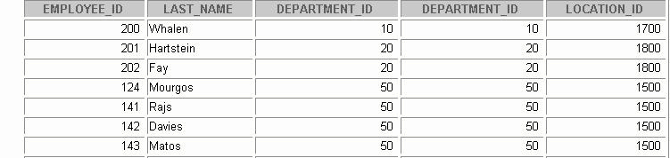
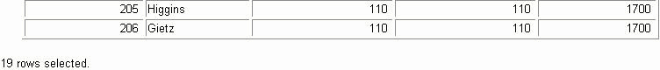
Retrieving Records
with Equijoins
SELECT employees.employee_id, employees.last_name,
employees.department_id, departments.department_id,
departments.location_id
FROM employees, departments
WHERE employees.department_id = departments.department_id;

Additional Search Conditions
Using the AND Operator
EMPLOYEES DEPARTMENTS
SELECT last_name, employees.department_id,
department_name
FROM employees, departments
WHERE employees.department_id = departments.department_id
AND last_name = 'Matos';
Qualifying Ambiguous Column Names
• Use table prefixes to qualify column names that
are in multiple tables.
• Improve performance by using table prefixes.
• Distinguish columns that have identical names but
reside in different tables by using column aliases.
Using Table Aliases
•Simplify queries by using table aliases
•Improve performance by using table prefixes
SELECT e.employee_id, e.last_name, e.department_id,
d.department_id, d.location_id
FROM employees e, departments d
WHERE e.department_id = d.department_id;
Joining More than Two Tables
EMPLOYEES
DEPARTMENTS
LOCATIONS
To join n tables together, you need a minimum of
n -1
join conditions. For example, to join three tables, a
minimum of two joins is required.

SELECT e.last_name, d.department_name, l.city
FROM employees e, departments d, locations l
WHERE e.department_id = d.department_id
AND d.location_id = l.location_id;
Nonequijoins
EMPLOYEES JOB_GRADES
Salary in the EMPLOYEES
table must be between
lowest salary and highest
salary in the JOB_GRADES table.
Retrieving Records with Nonequijoins
SELECT e.last_name, e.salary, j.grade_level
FROM employees e, job_grades j
WHERE e.salary BETWEEN j.lowest_sal AND j.highest _sal;
Outer Joins
DEPARTMENTS EMPLOYEES
There are no employees in
department 190.
SELECT e.last_name, e.department_id, d.department_name
FROM employees e, departments d
WHERE e.department_id = d.department_id;
Outer Joins Syntax
• You use an outer join to also see rows that do not
meet the join condition.
• The outer join operator is the plus sign (+).
SELECT table1.column, table2.column
FROM table1, table2
WHERE table1.column(+) = table2.column;
SELECT table1.column, table2.column
FROM table1, table2
WHERE table1.column = table2.column(+);
Using Outer Joins
SELECT e.last_name, e.department_id, d.department_name
FROM employees e, departments d
WHERE e.department_id(+) = d.department_id;
Self Joins
EMPLOYEES (WORKER) EMPLOYEES (MANAGER)
MANAGER_ID in the WORKER table is equal to
EMPLOYEE_ID in the MANAGER
table.
Joining a Table to Itself
SELECT worker.last_name || ' works for '
|| manager.last_name
FROM employees worker, employees manager
WHERE worker.manager_id = manager.employee_id;

Use a join to query data from more than one table.
SELECT table1.column, table2.column
FROM table1
[CROSS JOIN table2 ] | [NATURAL JOIN table2 ] | [JOIN table2
USING ( column_name )] | [JOIN table2 ON( table1.column_name
= table2.column_name )] | [LEFT|RIGHT|FULL OUTER JOIN
table2 ON ( table1.column_name = table2.column_name )];
Creating Cross Joins
•The CROSS JOIN clause produces the cross-
product of two tables.
• This is the same as a Cartesian product between
the two tables.
SELECT last_name, department_name
FROM employees
CROSS JOIN departments;
Creating Cross Joins
The example in the slide gives the same results as the following:
SELECT last_name, department_name FROM employees, departments;
Creating Natural Joins
• The NATURAL JOIN
clause is based on all columns in the two tables that have the same name.
• It selects rows from the two tables that have equal
values in all matched columns.
• If the columns having the same names have
different data types, then an error is returned.
Note: The join can happen only on columns having the same names and data types in both the tables. If the columns have the same name, but different data types, then the NATURAL JOIN syntax causes an error.

Retrieving Records with Natural Joins
SELECT department_id, department_name,
location_id, city
FROM departments
NATURAL JOIN locations;

SELECT department_id, department_name,
departments.location_id, city
FROM departments, locations
WHERE departments.location_id = locations.location_id;

SELECT department_id, department_name,
location_id, city
FROM departments
NATURAL JOIN locations
WHERE department_id IN (20, 50);
Creating Joins with the
USING Clause
• If several columns have the same names but the
data types do not match, the NATURAL JOIN
clause can be modified with the USING clause to
specify the columns that should be used for an
equijoin.
Note: Use the USING clause to match only one column
when more than one column matches.
• Do not use a table name or alias in the referenced
columns.
• The NATURAL JOIN and USING clauses are
mutually exclusive.

For example, this statement is valid:
SELECT l.city, d.department_name
FROM locations l JOIN departments d USING (location_id)
WHERE location_id = 1400;
This statement is invalid because the
LOCATION_ID
is qualified in the where clause:
SELECT l.city, d.department_name
FROM locations l JOIN departments d USING (location_id)
WHERE d.location_id = 1400;
ORA-25154: column part of USING clause cannot have qualifier
The same restriction applies to NATURAL
joins also. Therefore columns that have the same name in both
tables have to be used without any qualifiers.
Retrieving Records with the
USING Clause
SELECT e.employee_id, e.last_name, d.location_id
FROM employees e JOIN departments d
USING (department_id);

SELECT employee_id, last_name,
employees.department_id, location_id
FROM employees, departments
WHERE employees.department_id = departments.department_id;
Creating Joins with the
ON Clause
•The join condition for the natural join is basically
an equijoin of all columns with the same name.
•To specify arbitrary conditions or specify columns
to join, the ON clause is used.
•Separates the join condition from other search
conditions.
•The ON clause makes code easy to understand.

SELECT e.employee_id, e.last_name, e.department_id,
d.department_id, d.location_id
FROM employees e JOIN departments d
ON (e.department_id = d.department_id);

INNER versus OUTER Joins
• In SQL: 1999, the join of two tables returning only
matched rows is an inner join.
• A join between two tables that returns the results
of the inner join as well as unmatched rows left (or
right) tables is a left (or right) outer join.
• A join between two tables that returns the results
of an inner join as well as the results of a left and
right join is a full outer join.
Joins: Comparing SQL: 1999 to Oracle Syntax
LEFT OUTER JOIN
SELECT e.last_name, e.department_id, d.department_name
FROM employees e
LEFT OUTER JOIN departments d
ON (e.department_id = d.department_id);
Example of
LEFT OUTER JOIN
This query retrieves all rows in the
EMPLOYEES
table, which is the left table even if there is no match in
the DEPARTMENTS table.
This query was completed in earlier releases as follows:
SELECT e.last_name, e.department_id, d.department_name
FROM employees e, departments d
WHERE d.department_id (+) = e.department_id;
RIGHT OUTER JOIN
SELECT e.last_name, e.department_id, d.department_name
FROM employees e
RIGHT OUTER JOIN departments d
ON (e.department_id = d.department_id);
Example of
RIGHT OUTER JOIN
This query retrieves all rows in the DEPARTMENTS
table, which is the right table even if there is no match
in the EMPLOYEES table.
This query was completed in earlier releases as follows:
SELECT e.last_name, e.department_id, d.department_name
FROM employees e, departments d
WHERE d.department_id = e.department_id (+);
FULL OUTER JOIN
SELECT e.last_name, e.department_id, d.department_name
FROM employees e
FULL OUTER JOIN departments d
ON (e.department_id = d.department_id);

Additional Conditions
SELECT e.employee_id, e.last_name, e.department_id,
d.department_id, d.location_id
FROM employees e JOIN departments d
ON (e.department_id = d.department_id)
AND e.manager_id = 149;

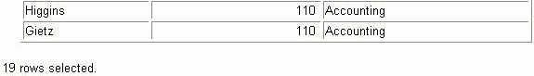

Practice 3, Part 1
1. Write a query to display the last name, department number, and department name for all employees.
2. Create a unique listing of all jobs that are in department 30. Include the location of department 90 in the output.
3. Write a query to display the employee last name, department name, location ID, and city of all employees who earn a commission.

4. Display the employee last name and department name for all employees who have an a (lowercase) in their last names. Place your SQL statement in a text file named lab4_4.sql.

5. Write a query to display the last name, job, department number, and department name for all employees who work in Toronto.
6. Display the employee last name and employee number along with their manager’s last name and manager number. Label the columns Employee ,
Emp# , Manager , and Mgr# , respectively.
Place your SQL statement in a text file named lab4_6.sql.

7. Modify lab4_6.sql to display all employees including King, who has no manager. Order the results by the employee number. Place your SQL statement in a text file named lab4_7.sql . Run the query in lab4_7.sql.
If you have time, complete the following exercises:
8. Create a query that displays employee last names, department numbers, and all the employees who work in the same department as a given employee. Give each column an appropriate label.

9. Show the structure of the JOB_GRADES table. Create a query that displays the name, job, department name, salary, and grade for all employees.
If you want an extra challenge, complete the following exercises:
10. Create a query to display the name and hire date of any employee hired after employee Davies.
11. Display the names and hire dates for all employees who were hire d before their managers, along with their manager’s names and hire dates. Label the columns Employee , Emp Hired , Manager , and Mgr Hired , respectively.

4-Aggregating Data
Using Group Functions
Objectives
After completing this lesson, you should be able to
do the following:
•Identify the available group functions
•Describe the use of group functions
•Group data using the GROUP BY clause
•Include or exclude grouped rows by using the
HAVING clause
What Are Group Functions?
Group functions operate on sets of rows to give one
result per group.
EMPLOYEES
The maximum
salary in the
EMPLOYEES table.
Types of Group Functions
• AVG
•COUNT
•MAX
•MIN
•SUM
Group Functions Syntax
SELECT [ column ,] group_function(column), ...
FROM table
[WHERE condition ]
[GROUP BY column ]
[ORDER BY column ];
Using the AVG and SUM Functions
You can use AVG and SUM for numeric data.
SELECT AVG(salary), MAX(salary),
MIN(salary), SUM(salary)
FROM employees
WHERE job_id LIKE '%REP%';
Using the MIN and MAX Functions
You can use MIN and MAX for any data type.
SELECT MIN(hire_date), MAX(hire_date)
FROM employees;

SELECT MIN(last_name), MAX(last_name)
FROM employees;
Note: AVG , SUM , VARIANCE , and STDDEV functions can be used only with numeric data types.
Using the COUNT Function COUNT(*)
returns the number of rows in a table.
SELECT COUNT(*)
FROM employees
WHERE department_id = 50;
Using the COUNT Function
• COUNT( expr ) returns the number of rows with
non-null values for the expr.
•Display the number of department values in the
EMPLOYEES table, excluding the null values.
SELECT COUNT(commission_pct)
FROM employees
WHERE department_id = 80;

SELECT COUNT(department_id)
FROM employees;

Using the DISTINCT Keyword
• COUNT(DISTINCT expr ) returns the number of
distinct nonnull values of the expr .
• Display the number of distinct department values
in the EMPLOYEES table.
SELECT COUNT(DISTINCT department_id)
FROM employees;
Group Functions and Null Values
Group functions ignore null values in the column.
SELECT AVG(commission_pct)
FROM employees;
Using the NVL Function
with Group Functions
The NVL function forces group functions to include
null values.
SELECT AVG(NVL(commission_pct, 0))
FROM employees;
Creating Groups of Data
EMPLOYEES
4400
9500
The average salary 3500 in EMPLOYEES
Table 6400 for each department.
Creating Groups of Data:
GROUP BY Clause Syntax
SELECT column , group_function(column)
FROM table
[WHERE condition ]
[GROUP BY group_by_expression ]
[ORDER BY column ];
Divide rows in a table into smaller groups by using the
Using the GROUP BY Clause
All columns in the SELECT list that are not in group
functions must be in the GROUP BY clause.
SELECT department_id, AVG(salary)
FROM employees
GROUP BY department_id;
Using the GROUP BY Clause
Using the GROUP BY Clause
The GROUP BY column does not have to be in the
SELECT list.
SELECT AVG(salary)
FROM employees
GROUP BY department_id;
SELECT department_id, AVG(salary)
FROM employees
GROUP BY department_id
ORDER BY AVG(salary);
Grouping by More Than One Column
EMPLOYEES
Add up the salaries in the
EMPLOYEES table
for each job,
grouped by
department.

Using theGROUP BY Clause
on Multiple Columns
SELECT department_id dept_id, job_id, SUM(salary)
FROM employees
GROUP BY department_id, job_id;

Illegal Queries
Using Group Functions
Any column or expression in the
SELECT list that is not an aggregate function must be in the GROUP BY clause.
SELECT department_id, COUNT(last_name)
FROM employees;
SELECT department_id, COUNT(last_name)
*
ERROR at line 1:
ORA-00937: not a single-group group function

SELECT department_id, count(last_name)
FROM employees
GROUP BY department_id;
Any column or expression in the SELECT list that is not an aggregate function must be in the GROUP BY clause.
Illegal Queries
Using Group Functions
• You cannot use the WHERE clause to restrict groups.
• You use the HAVING clause to restrict groups.
• You cannot use group functions in the WHERE
clause.
SELECT department_id, AVG(salary)
FROM employees
WHERE AVG(salary) > 8000
GROUP BY department_id;
WHERE AVG(salary) > 8000
*
ERROR at line 3:
ORA-00934: group function is not allowed here
Illegal Queries Using Group Functions (continued)
SELECT department_id, AVG(salary)
FROM employees
HAVING AVG(salary) > 8000
GROUP BY department_id;
Excluding Group Results
EMPLOYEES
The maximum
salary
per department
when it is
greater than
$10,000.
Excluding Group Results: The HAVING
Clause
Use the HAVING clause to restrict groups:
1. Rows are grouped.
2. The group function is applied.
3. Groups matching the
HAVING clause are displayed.
SELECT column , group_function
FROM table
[WHERE condition]
[GROUP BY group_by_expression ]
[HAVING group_condition]
[ORDER BY column ];

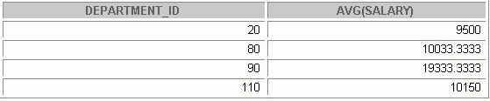
Using the HAVING Clause
SELECT department_id, MAX(salary)
FROM employees
GROUP BY department_id
HAVING MAX(salary)>10000;
Using the HAVING Clause
SELECT department_id, AVG(salary)
FROM employees
GROUP BY department_id
HAVING max(salary)>10000;
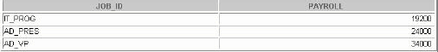
Using the HAVING Clause
SELECT job_id, SUM(salary) PAYROLL
FROM employees
WHERE job_id NOT LIKE '%REP%'
GROUP BY job_id
HAVING SUM(salary) > 13000
ORDER BY SUM(salary);
.
Nesting Group Functions
Display the maximum average salary.
SELECT MAX(AVG(salary))
FROM employees
GROUP BY department_id;

Paper-Based Questions
For questions 1 through 3, circle either True or False.
Note:
Column aliases are used for the queries.

Practice 4
Determine the validity of the following three statements. Circle either True or False.
1. Group functions work across many rows to produce one result per group.
True/False
2. Group functions include nulls in calculations.
True/False
3. The WHERE clause restricts rows prior to inclusion in a group calculation
True/False
4. Display the highest, lowest, sum, and average salary of all employees. Label the columns Maximum , Minimum , Sum , and Average , respectively. Round your results to the nearest whole number. Place your SQL statement in a text file named lab5_6.sql.
5. Modify the query in lab5_4.sql to display the minimum, maximum, sum, and average salary for each job type. Resave lab5_4.sql To lab5_5.sql. Run the statement in lab5_5.sql.

6. Write a query to display the number of people with the same job.
7. Determine the number of managers without listing them. Label the column
Number of Managers .
Hint:Use the MANAGER_ID column to determine the number of managers.
8. Write a query that displays the difference between the highest a nd lowest salaries. Label the column DIFFERENCE.
If you have time, complete the following exercises:
9. Display the manager number and the salary of the lowest paid employee for that manager.
Exclude anyone whose manager is not known. Exclude any groups where the minimum salary is less than $6,000. Sort the output in descending order of salary.

10. Write a query to display each department’s name, location, number of employees, and the average salary for all employees in that department. Label the columns Name , Location , Number of People , and Salary , respectively. Round the average salary to two decimal places.
If you want an extra challenge, complete the following exercises:
11. Create a query that will display the total number of employees a nd, of that total, the number of employees hired in 1995, 1996, 1997, and 1998. Create appropriate column headings.
12. Create a matrix query to display the job, the salary for that job based on department number, and the total salary for that job, for departments 20, 50, 80, and 90, giving each column an appropriate heading.

Subqueries Objectives
After completing this lesson, you should be able to
do the following:
• Describe the types of problem that subqueries can solve
• Define subqueries
• List the types of subqueries
• Write single-row and multiple-row subqueries
Using a Subquery to Solve a Problem
Who has a salary greater than Abel’s?
Main Query: Which employees have salaries greater?
than Abel’s salary?
Subquery: ?
What is Abel’s salary?
Subquery Syntax
SELECT select_list
FROM table
WHERE expr operator
(SELECT select_list
FROM table );
•The subquery (inner query) executes once before
the main query.
•The result of the subquery is used by the main
output is used to complete the query condition for the main or outer query.
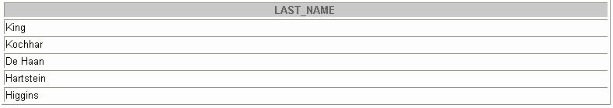
Using a Subquery
SELECT last_name
FROM employees
11000
WHERE salary >
(SELECT salary
FROM employees
WHERE last_name = 'Abel');

Types of Subqueries
• Single-row subquery Main query returns
ST_CLERK Subquery
• Multiple-row subquery Main query
ST_CLERK returns Subquery
SA_MAN
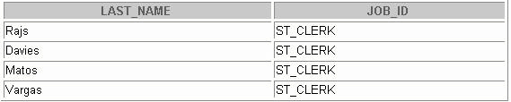
Single-Row Subqueries
•Return only one row
•Use single-row comparison operators
Operator Meaning
= Equal to
> Greater than
>= Greater than or equal to
< Less than
<= Less than or equal to
<> Not equal to
Example
Display the employees whose job ID is the same as that of employee 141.
SELECT last_name, job_id FROM employees WHERE job_id =
(SELECT job_id FROM employees WHERE employee_id = 141);
Executing Single-Row Subqueries
SELECT last_name, job_id, salary
FROM employees
WHERE job_id =
ST_CLERK
(SELECT job_id
FROM employees
WHERE employee_id = 141)
AND salary >
2600
(SELECT salary
FROM employees
WHERE employee_id = 143);
Using Group Functions in a Subquery
SELECT last_name, job_id, salary
FROM employees
2500
WHERE salary =
(SELECT MIN(salary)
FROM employees);
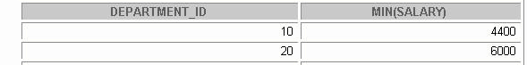
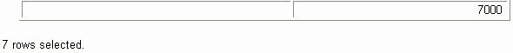
The HAVING Clause with Subqueries
•The Oracle Server executes subqueries first.
•The Oracle Server returns results into the
HAVING clause of the main query.
SELECT department_id, MIN(salary)
FROM employees
GROUP BY department_id
2500
HAVING MIN(salary) >
(SELECT MIN(salary)
FROM employees
WHERE department_id = 50);
Example
Find the job with the lowest average salary.
SELECT job_id, AVG(salary)
FROM employees
GROUP BY job_id
HAVING AVG(salary) = (SELECT MIN(AVG(salary))
FROM employees
GROUP BY job_id);
What Is Wrong with This Statement?
SELECT employee_id, last_name
FROM employees
WHERE salary =
(SELECT MIN(salary)
FROM employees
GROUP BY department_id);
ERROR at line 4:
ORA-01427: single-row subquery returns more than
one row
Will This Statement Return Rows?
SELECT last_name, job_id
FROM employees
WHERE job_id =
(SELECT job_id
FROM employees
WHERE last_name = 'Haas');
no rows selected
Multiple-Row Subqueries
•Return more than one row
•Use multiple-row comparison operators
Operator Meaning
IN Equal to any member in the list
ANY Compare value to each value returned by
the subquery
Compare value to every value returned
ALL by the subquery
SELECT last_name, salary, department_id
FROM employees
WHERE salary IN (SELECT MIN(salary)
FROM employees
GROUP BY department_id);
Example
Find the employees who earn the same salary as the minimum salar y for each department. The inner query is executed first, producing a query result. The main query block is then processed and uses the values returned by the inner query to complete its sear ch condition. In fact, the main query would
look like the following to the Oracle Server:
SELECT last_name, salary, department_id
FROM employees
WHERE salary IN (2500, 4200, 4400, 6000, 7000, 8300, 8600, 1 7000);
Using the ANY Operator
in Multiple-Row Subqueries
SELECT employee_id, last_name, job_id, salary
FROM employees
9000, 6000, 4200
WHERE salary < ANY
(SELECT salary
FROM employees
WHERE job_id = 'IT_PROG')
AND job_id <> 'IT_PROG';
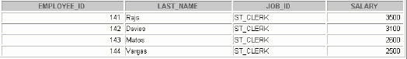
Using the ALL Operator
in Multiple-Row Subqueries
SELECT employee_id, last_name, job_id, salary
FROM employees
WHERE salary < ALL
9 00 0 , 6 0 00 , 42 0 0
(SELECT salary
FROM employees
WHERE job_id = 'IT_PROG')
AND job_id <> 'IT_PROG';

Null Values in a Subquery
SELECT emp.last_name
FROM employees emp
WHERE emp.employee_id NOT IN
(SELECT mgr.manager_id
FROM employees mgr);
no rows selected

Practice 5
1. Write a query to display the last name and hire date of any employee in the same department as Zlotkey. Exclude Zlotkey.
2. Create a query to display the employee numbers and last names of all employees who earn more than the average salary. Sort the results in ascending order of salary.
3. Write a query that displays the employee numbers and last names of all employees who work in a department with any employee whose last name contains a u. Place your SQL statement in a text file named
lab6_3.sql. Run your query.
4. Display the last name, department number, and job ID of all employees whose department location ID is 1700.
5. Display the last name and salary of every employee who reports to King.
6. Display the department number, last name, and job ID for every employee in the Executive department.
If you have time, complete the following exercises:
7. Modify the query in lab6_3.sql to display the employee numbers, last names, and salaries of all employees who earn more than the average salary and who work in a department with any employee with a u in their name. Resave lab6_3.sql to lab6_7.sql . Run the statement in lab6_7.sql.

6-Manipulating Data Objectives
After completing this lesson, you should be able to
do the following:
• Describe each DML statement
• Insert rows into a table
• Update rows in a table
• Delete rows from a table
• Merge rows in a table
• Control transactions
Data Manipulation Language
• A DML statement is executed when you:
–Add new rows to a table
–Modify existing rows in a table
–Remove existing rows from a table
•A transaction consists of a collection of DML
statements that form a logical unit of work.
Adding a New Row to a Table
New row DEPARTMENTS
Insert a new row into the
DEPARMENTS
table.
The INSERT Statement Syntax
• Add new rows to a table by using the
INSERT statement.
INSERT INTO table[(
column[, column...])]
VALUES(value[, value...]);
•Only one row is inserted at a time with this syntax.
Adding a New Row to a Table (continued)
Note: This statement with the VALUES clause adds only one row at a time to a table.
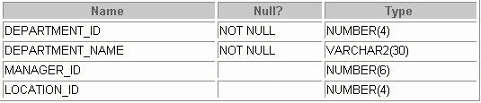
Inserting New Rows
• Insert a new row containing values for each
column.
•List values in the default order of the columns in
the table.
•Optionally, list the columns in the INSERT clause.
INSERT INTO departments(department_id, department_name,
manager_id, location_id)
VALUES (70, 'Public Relations', 100, 1700);
1 row created.
•Enclose character and date values within single
quotation marks.
Inserting Rows with Null Values
• Implicit method: Omit the column from the
column list.
INSERT INTO departments (department_id,
department_name )
VALUES (30, 'Purchasing');
1 row created.
•Explicit method: Specify the NULL
keyword in the VALUES clause.
INSERT INTO departments
VALUES (100, 'Finance', NULL, NULL);
1 row created.
Inserting Special Values
The SYSDATE function records the current date
and time.
INSERT INTO employees (employee_id,
first_name, last_name,
email, phone_number,
hire_date, job_id, salary,
commission_pct, manager_id,
department_id)
VALUES (113, 'Louis', 'Popp', 'LPOPP', '515.124.4567',
SYSDATE, 'AC_ACCOUNT', 6900, NULL, 205, 100);
1 row created.
Confirming Additions to the Table
SELECT employee_id, last_name, job_id, hire_date, commission _pct
FROM employees
WHERE employee_id = 113;
Inserting Specific Date Values
•Add a new employee.
INSERT INTO employees
VALUES (114,
'Den', 'Raphealy',
'DRAPHEAL', '515.127.4561',
TO_DATE('FEB 3, 1999', 'MON DD, YYYY'),
'AC_ACCOUNT', 11000, NULL, 100, 30);
1 row created.
•Verify your addition.
INSERT INTO departments
(department_id, department_name, location_id)
VALUES (&department_id, '&department_name',&location);
40
Human Resources
2500
1 row created.
Copying Rows from Another Table
• Write your INSERT statement with a subquery.
INSERT INTO sales_reps(id, name, salary, commission_pct)
SELECT employee_id, last_name, salary, commission_pct
FROM employees
WHERE job_id LIKE '%REP%';
4 rows created.
•Do not use the VALUES clause.
• Match the number of columns in the INSERT clause to those in the subquery.

INSERT INTO copy_emp SELECT *
FROM employees;

The UPDATE Statement Syntax
•Modify existing rows with the
UPDATE
statement.
UPDATE table SET column = value [, column = value, ... ]
[WHERE condition ];
•Update more than one row at a time, if required.
Note: In general, use the primary key to identify a single row. Using other columns can unexpectedly cause several rows to be updated. For example, identifying a single row in the EMPLOYEES table by name is dangerous, because more than one employee may have the same name.
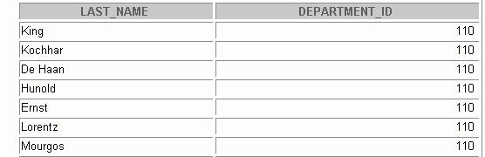
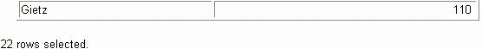
Updating Rows in a Table
•Specific row or rows are modified if you specify
The WHERE clause.
UPDATE employees
SET department_id = 70
WHERE employee_id = 113;
1 row updated.
• All rows in the table are modified if you omit the
WHERE clause.
UPDATE copy_emp
SET department_id = 110;
22 rows updated.
Updating Two Columns with a Subquery
Update employee 114’s job and department to match
that of employee 205.
UPDATE employees
SET job_id = (SELECT job_id
FROM employees
WHERE employee_id = 205),
salary = (SELECT salary
FROM employees
WHERE employee_id = 205)
WHERE employee_id = 114;
1 row updated.
Updating Rows Based
on Another Table
Use subqueries in UPDATE statements to update
rows in a table based on values from another table.
UPDATE copy_emp
SET department_id = (SELECT department_id
FROM employees
WHERE employee_id = 100)
WHERE job_id = (SELECT job_id
FROM employees
WHERE employee_id = 200);
1 row updated.
Updating Rows:
Integrity Constraint Error
UPDATE employees
SET department_id = 55
WHERE department_id = 110;
UPDATE employees
*
ERROR at line 1:
ORA-02291: integrity constraint (HR.EMP_DEPT_FK)
violated - parent key not found
Integrity Constraint Error
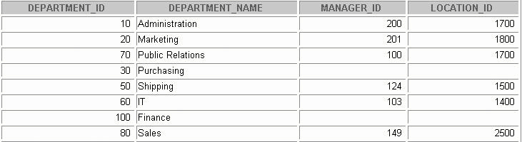
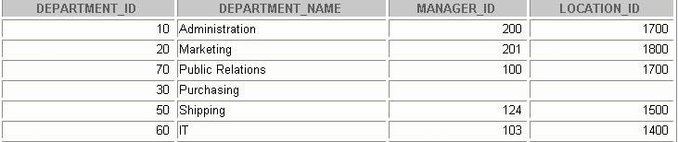
Removing a Row from a Table
DEPARTMENTS
Delete a row from the
DEPARTMENTS
table.
The DELETE Statement
You can remove existing rows from a table by using
The DELETE statement.
DELETE [FROM] table
[WHERE condition ];
Note:If no rows are deleted, a message “
0 rows deleted .” is returned:
Deleting Rows from a Table
•Specific rows are deleted if you specify the
WHERE clause.
DELETE FROM departments
WHERE department_name = 'Finance';
1 row deleted.
•All rows in the table are deleted if you omit the
WHERE clause.
DELETE FROM copy_emp;
22 rows deleted.
Example
Remove rows identified in the WHERE clause.
DELETE FROM employees
WHERE employee_id = 114;
1 row deleted.
DELETE FROM departments
WHERE department_id IN (30, 40);
2 rows deleted.

Deleting Rows Based
on Another Table
Use subqueries in DELETE
statements to remove
rows from a table based on values from another table.
DELETE FROM employees
WHERE department_id =
(SELECT department_id
FROM departments
WHERE department_name LIKE '%Public%');
1 row deleted.
Deleting Rows:
Integrity Constraint Error
DELETE FROM departments
WHERE department_id = 60;
DELETE FROM departments
*
ERROR at line 1:
ORA-02292: integrity constraint (HR.EMP_DEPT_FK)
violated - child record found
Integrity Constraint Error
The following statement works because there are no employees in department 70:
DELETE FROM departments WHERE department_id = 70;
1 row deleted.
Using a Subquery in an
INSERT Statement
INSERT INTO
(SELECT employee_id, last_name,
email, hire_date, job_id, salary,
department_id
FROM employees
WHERE department_id = 50)
VALUES (99999, 'Taylor', 'DTAYLOR',
TO_DATE('07-JUN-99', 'DD-MON-RR'),
'ST_CLERK', 5000, 50);
1 row created.
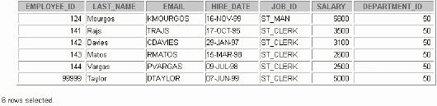
Using a Subquery in an
INSERT Statement
•Verify the results
SELECT employee_id, last_name, email, hire_date,
job_id, salary, department_id
FROM employees
WHERE department_id = 50;
Using the WITH CHECK OPTION
Keyword on DML Statements
•A subquery is used to identify the table and
columns of the DML statement.
•The WITH CHECK OPTION
keyword prohibits you from changing rows that are not in the subquery.
INSERT INTO (SELECT employee_id, last_name, email,
hire_date, job_id, salary
FROM employees
WHERE department_id = 50 WITH CHECK OPTION)
VALUES (99998, 'Smith', 'JSMITH',
TO_DATE('07-JUN-99', 'DD-MON-RR'),
'ST_CLERK', 5000);
INSERT INTO
*
ERROR at line 1:
ORA-01402: view WITH CHECK OPTION where-clause violation
The MERGE Statement
•Provides the ability to conditionally update or
insert data into a database table
•Performs an
UPDATE
if the row exists and an
INSERT
if it is a new row:
–Avoids separate updates
–Increases performance and ease of use
–Is useful in data warehousing applications
MERGE
Statement Syntax
You can conditionally insert or update rows in a
table by using the MERGE statement.
MERGE INTO table_name
AS table_alias
USING ( table|view|sub_query) AS alias
ON (join condition)
WHEN MATCHED THEN
UPDATE SET
col1 = col_val1,
col2 = col2_val
WHEN NOT MATCHED THEN
INSERT (column_list)
VALUES (column_values);
Merging Rows
Insert or update rows in the
OPY_EMP table to match the
EMPLOYEES table.
MERGE INTO copy_emp AS c
USING employees e
ON (c.employee_id = e.employee_id)
WHEN MATCHED THEN
UPDATE SET
c.first_name = e.first_name,
c.last_name = e.last_name,
...
c.department_id = e.department_id
WHEN NOT MATCHED THEN
INSERT VALUES(e.employee_id, e.first_name, e.last_name,
e.email, e.phone_number, e.hire_date, e.job_id,
e.salary, e.commission_pct, e.manager_id,
e.department_id);
Merging Rows: Example
MERGE INTO copy_emp AS c
USING employees e
ON (c.employee_id = e.employee_id)
WHEN MATCHED THEN
UPDATE SET
c.first_name = e.first_name,
c.last_name = e.last_name,
c.email = e.email,
c.phone_number = e.phone_number,
c.hire_date = e.hire_date,
c.job_id = e.job_id,
c.salary = e.salary,
c.commission_pct = e.commission_pct,
c.manager_id = e.manager_id,
c.department_id = e.department_id
WHEN NOT MATCHED THEN
INSERT VALUES(e.employee_id, e.first_name, e.last_name,
e.email, e.phone_number, e.hire_date, e.job_id,
e.salary, e.commission_pct, e.manager_id,
e.department_id);
Merging Rows
SELECT *
FROM COPY_EMP;
no rows selected
MERGE INTO copy_emp c
USING employees e
ON (c.employee_id = e.employee_id)
WHEN MATCHED THEN
UPDATE SET
...
WHEN NOT MATCHED THEN
INSERT VALUES...;
SELECT *
FROM COPY_EMP;
20 rows selected.
Database Transactions
A database transaction consists of one of the
following:
•DML statements which constitute one consistent
change to the data
•One DDL statement
•One DCL statement
Database Transactions
•Begin when the first DML SQL statement is
executed
•End with one of the following events:
–A COMMIT or ROLLBACK statement is issued
–A DDL or DCL statement executes (automatic commit)
–The user exits iSQL*Plus
–The system crashes

Advantages of COMMIT and ROLLBACK
Statements With COMMIT and ROLLBACK
statements, you can:
•Ensure data consistency
•Preview data changes before making changes
permanent
•Group logically related operations
Controlling Transactions
COMMIT Time
Transaction
DELETE
SAVEPOINT A
INSERT
UPDATE
SAVEPOINT B
INSERT
ROLLBACK
ROLLBACK
ROLLBACK
to SAVEPOINT A
to SAVEPOINT B
Note:SAVEPOINT is not ANSI standard SQL.
Rolling Back Changes to a Marker
• Create a marker in a current transaction by using
The SAVEPOINT statement.
•Roll back to that marker by using the ROLLBACK
TO SAVEPOINT statement.
UPDATE... SAVEPOINT update_done;
Savepoint created.
INSERT...
ROLLBACK TO update_done;
Rollback complete.
Implicit Transaction Processing
• An automatic commit occurs under the following
circumstances:
–DDL statement is issued
–DCL statement is issued
–Normal exit from iSQL*Plus, without explicitly
Issuing COMMIT or ROLLBACK statements
•An automatic rollback occurs under an abnormal
termination of iSQL*Plus or a system failure.
Implicit Transaction Processing
Status Circumstances
State of the Data Before COMMIT
Or ROLLBACK
•The previous state of the data can be recovered.
•The current user can review the results of the DML
operations by using the SELECT statement.
•Other users cannot view the results of the DML
statements by the current user.
• The affected rows are locked; other users cannot change
the data within the affected rows.
State of the Data After COMMIT
•Data changes are made permanent in the database.
•The previous state of the data is permanently lost.
•All users can view the results.
•Locks on the affected rows are released; those rows
are available for other users to manipulate.
•All savepoints are erased.
Committing Data
•Make the changes.
DELETE FROM employees
WHERE employee_id = 99999;
1 row deleted.
INSERT INTO departments
VALUES (290, 'Corporate Tax', NULL, 1700);
1 row inserted.
•Commit the changes.
COMMIT;
Commit complete.
Example
Remove departments 290 and 300 in the DEPARTMENTS table, and update a row in the COPY_EMP table. Make the data change permanent.
DELETE FROM departments
WHERE department_id IN (290, 300);
2 rows deleted.
UPDATE copy_emp
SET department_id = 80
WHERE employee_id = 206;
1 row updated.
COMMIT;
Commit Complete.
State of the Data After ROLLBACK
Discard all pending changes by using the
ROLLBACK
statement:
•Data changes are undone.
•Previous state of the data is restored.
•Locks on the affected rows are released.
DELETE FROM copy_emp;
22 rows deleted.
ROLLBACK;
Rollback complete.
Rolling Back Changes
DELETE FROM test;
25,000 rows deleted.
ROLLBACK;
Rollback complete.
DELETE FROM test
WHERE id = 100;
1 row deleted.
SELECT *
FROM test
WHERE id = 100;
No rows selected.
COMMIT;
Commit complete.
Statement-Level Rollback
•If a single DML statement fails during execution,
only that statement is rolled back.
• The Oracle Server implements an implicit
savepoint.
•All other changes are retained.
•The user should terminate transactions explicitly
by executing a COMMIT or ROLLBACK
statement.
Read Consistency
•Read consistency guarantees a consistent view of
the data at all times.
•Changes made by one user do not conflict with
changes made by another user.
•Read consistency ensures that on the same data:
–Readers do not wait for writers
–Writers do not wait for readers

Implementation of Read Consistency
User A Data
UPDATE employees blocks
SET salary = 7000
WHERE last_name = 'Goyal';
Undo segments changed and
SELECT *
Read unchanged
FROM userA.employees;
Data consistent before image change: “old” data
User B
Locking
In an Oracle database, locks:
•Prevent destructive interaction between
concurrent transactions
•Require no user action
•Use the lowest level of restrictiveness
•Are held for the duration of the transaction
•Are of two types: explicit locking and implicit locking
What Are Locks?
Locks are mechanisms that prevent destructive interaction between tra nsactions accessing the same resource, either a user object (such as tables or rows) or a system object not visible to users (such as shared data structures and data dictionary rows).
How the Oracle Database Locks Data
Locking is performed automatically and requires no user action. Implicit locking occurs for SQL statements as necessary, depending on the action requested. Implicit locking occurs for all SQL statements except SELECT.
The users can also lock data manually, which is called explicit locking.
Implicit Locking
•Two lock modes:
–Exclusive: Locks out other users
–Share: Allows other users to access the server
•High level of data concurrency:
–DML: Table share, row exclusive
–Queries: No locks required
–DDL: Protects object definitions
•Locks held until commit or rollback
DML Locking
When performing data manipulation language (DML) operations, the Oracle Server provides data concurrency through DML locking. DML locks occur at two levels:
• A share lock is automatically obtained at the table level during DML operations. With share lock mode, several transactions can acquire share locks on the same resource.
• An exclusive lock is acquired automatically for each row modified by a DML statement. Exclusive locks prevent the row from being changed by other transactions until the transaction is committed or rolled back. This lock ensures that no other user can modify the same row at the same time and
overwrite changes not yet committed by another user.
Note: DDL locks occur when you modify a database object such as a table.

Practice 6
Insert data into the MY_EMPLOYEE table.
1. Run the statement in the lab8_1.sql script to build the MY_EMPLOYEE
table to be used for the lab.
2. Describe the structure of the MY_EMPLOYEE table to identify the column names.
3. Add the first row of data to the MY_EMPLOYEE table from the following sample data. Do not list the columns in the INSERT clause.
ID LAST_NAME FIRST_NAME USERID SALARY
1 Patel Ralph rpatel 895
2 Dancs Betty bdancs 860
3 Biri Ben bbiri 1100
4 Newman Chad cnewman 750
5 Ropeburn Audrey aropebur 1550
4. Populate the MY_EMPLOYEE table with the second row of sample data from the preceding list. This time, list the columns explicitly in the INSERT
clause.
5. Confirm your addition to the table.

6. Write an INSERT statement in a text file named loademp.sql
to load rows into the MY_EMPLOYEE table. Concatenate the first letter of the first name and the f irst seven characters of the last name to produce the user ID.
7. Populate the table with the next two rows of sample data by runn ing the
INSERT statement in the script that you created.
8. Confirm your additions to the table.
9. Make the data additions permanent.
Update and delete data in the MY_EMPLOYEE table.
10. Change the last name of employee 3 to Drexler.
11. Change the salary to 1000 for all employees with a salary less than 900.
12. Verify your changes to the table.
13. Delete Betty Dancs from the MY_EMPLOYEE table.
14. Confirm your changes to the table.
15. Commit all pending changes. Control data transaction to the
MY_EMPLOYEE table.
16. Populate the table with the last row of sample data by modifying the statements in the script that you created in step 6. Run the statements in the script.
17. Confirm your addition to the table.
18. Mark an intermediate point in the processing of the transaction.
19. Empty the entire table.
20. Confirm that the table is empty.
21. Discard the most recent DELETE operation without discarding the earlier
INSERT operation.
22. Confirm that the new row is still intact.
23. Make the data addition permanent.

Creating and Managing Tables
Objectives
After completing this lesson, you should be able to
do the following:
•Describe the main database objects
•Create tables
•Describe the data types that can be used when
specifying column definition
•Alter table definitions
•Drop, rename, and truncate tables
The CREATE TABLE Statement
•You must have:
–CREATE TABLE privilege
–A storage area
CREATE TABLE[schema.]table(column datatype[DEFAULTexpr][, ...]);
•You specify:
–Table name
–Column name, column data type, and column size
Referencing Another User’s Tables
•Tables belonging to other users are not in the
user’s schema.
•You should use the owner’s name as a prefix to
those tables.
SELECT *
FROM user_b.employees;
Creating Tables
•Create the table.
CREATE TABLE dept
(deptno NUMBER(2),
dname VARCHAR2(14),
loc VARCHAR2(13));
Table created.
•Confirm creation of the table.
DESCRIBE dept
Tables in the Oracle Database
•User tables:
–Are a collection of tables created and maintained by
the user
–Contain user information
•Data dictionary:
–Is a collection of tables created and maintained by
the Oracle Server
–Contain database information
Querying the Data Dictionary
•See the names of tables owned by the user.
SELECT table_name FROM user_tables;
•View distinct object types owned by the user.
SELECT DISTINCT object_type
FROM user_objects;
•View tables, views, synonyms, and sequences owned by
the user.
SELECT * FROM user_catalog;
Creating a Table
by Using a Subquery Syntax
•Create a table and insert rows by combining the
CREATE TABLE
statement and the
AS
Subquery option.
CREATE TABLE
table[(column,column...)] AS subquery;
•Match the number of specified columns to the
number of subquery columns.
•Define columns with column names and
default values.

CREATE TABLE dept80
AS
SELECT employee_id, last_name,
salary*12 ANNSAL,
hire_date
FROM employees
WHERE department_id = 80;
Table created.
The ALTER TABLE Statement
Use the ALTER TABLE statement to:
•Add a new column
•Modify an existing column
•Define a default value for the new column
•Drop a column

The ALTER TABLE Statement
Use the ALTER TABLE statement to add, modify or drop
columns.
ALTER TABLE table ADD ( column datatype [DEFAULT expr]
[, column datatype]...);
ALTER TABLE table MODIFY ( column datatype [DEFAULT
Expr ] [, column datatype ]...);
ALTER TABLE table
DROP ( column );
The ALTER TABLE
Adding a Column
•Use the ADD clause to add columns.
ALTER TABLE dept80
ADD (job_id VARCHAR2(9));
Table altered.
Modifying a Column
• You can change a column’s data type, size, and
default value.
ALTER TABLE dept80
MODIFY (last_name VARCHAR2(30));
Table altered.
• A change to the default value affects only
subsequent insertions to the table.
Dropping a Column
Use the DROP COLUMN
clause to drop columns you no
longer need from the table.
ALTER TABLE dept80
DROP COLUMN job_id;
Table altered.
The SET UNUSED Option
•You use the SET UNUSED option to mark one or
more columns as unused.
•You use the DROP UNUSED COLUMNS
option to remove the columns that are marked as unused.
ALTER TABLE table SET UNUSED ( column );
OR
ALTER TABLE table COLUMN column;
SET UNUSED ALTER TABLE table
DROP UNUSED COLUMNS;

ALTER TABLE dept80
SET UNUSED (last_name);
Table altered.
ALTER TABLE dept80
DROP UNUSED COLUMNS;
Table altered.
Dropping a Table
• All data and structure in the table is deleted.
•Any pending transactions are committed.
•All indexes are dropped.
•You cannot roll back the DROP TABLE statement.
DROP TABLE dept80;
Table dropped.
Changing the Name of an Object
•To change the name of a table, view, sequence, or
synonym, execute the RENAME statement.
RENAME dept TO detail_dept;
Table renamed.
•You must be the owner of the object.
Truncating a Table
• The TRUNCATE TABLE statement:
– Removes all rows from a table
–Releases the storage space used by that table
TRUNCATE TABLE detail_dept;
Table truncated.
•You cannot roll back row removal when using
TRUNCATE.
•Alternatively, you can remove rows by using the
DELETE statement.
Adding Comments to a Table
• You can add comments to a table or column by using
The COMMENT statement.
COMMENT ON TABLE employees
IS 'Employee Information';
Comment created.
•Comments can be viewed through the data dictionary
views:
–ALL_COL_COMMENTS
–USER_COL_COMMENTS
–ALL_TAB_COMMENTS
–USER_TAB_COMMENTS

Practice 7
1. Create the DEPT table based on the following table instance chart. Place the syntax in a script called lab9_1.sql , then execute the statement in the script to create the table.
Confirm that the table is created.
ID NAME Column Name Key Type Nulls/Unique FK Table FK Column
NUMBER VARCHAR2 Data type 7 25 Length
2. Populate the DEPT table with data from the DEPARTMENTS
table. Include only columns that you need.
3. Create the EMP table based on the following table instance chart. Place the syntax in a script called lab9_3.sql , and then execute the statement in the script to create the table. Confirm that the table is created. ID LAST_NAME FIRST_NAME DEPT_ID
Column Name
Key Type
Nulls/Unique
FK Table
FK Column
NUMBER VARCHAR2 VARCHAR2 NUMBER
Data type Length 7 25 25 7

4. Modify the EMP table to allow for longer employee last names. Confirm your modification.
5. Confirm that both the DEPT and EMP tables are stored in the data dictionary. (Hint:USER_TABLES)
6. Create the EMPLOYEES2 table based on the structure of the
EMPLOYEES table. Include only the
EMPLOYEE_ID , FIRST_NAME , LAST_NAME , SALARY , and
DEPARTMENT_ID columns. Name the columns in your new table
ID , FIRST_NAME , LAST_NAME , SALARY , and DEPT_ID ,
respectively.
7. Drop the EMP table.
8. Rename the EMPLOYEES2 table as EMP.
9. Add a comment to the DEPT and EMP table definitions describing the ables. Confirm your additions in the data dictionary.
10. Drop the FIRST_NAME column from the EMP table. Confirm your modification by checking the description of the table.
11. In the EMP table, mark the DEPT_ID column in the EMP table as
UNUSED . Confirm your modification by checking the description of the table.
12. Drop all the UNUSED columns from the EMP table. Confirm your modification by checking the description of the table.

8- Constraints
Objectives
After completing this lesson, you should be able to
do the following:
• Describe constraints
•Create and maintain constraints
What Are Constraints?
•Constraints enforce rules at the table level.
•Constraints prevent the deletion of a table if there are
dependencies.
•The following constraint types are valid:
–NOT NULL
–UNIQUE
–PRIMARY KEY
–FOREIGN KEY
–CHECK
Defining Constraints
CREATE TABLE [schema.]table(column datatype
[DEFAULTexpr][column_constraint],...[table_constraint
][,...]);
CREATE TABLE employees(
employee_id NUMBER(6),
first_name VARCHAR2(20),
...
job_id VARCHAR2(10) NOT NULL,
CONSTRAINT emp_emp_id_pk
PRIMARY KEY (EMPLOYEE_ID));
Defining Constraints
•Column constraint level:
Column [CONSTRAINT constraint_name ]
constraint_type ,
•Table constraint level:
column,...[CONSTRAINT constraint_name]
constraint_type(column, ...),
The NOT NULL Constraint
Ensures that null values are not permitted for the
The NOT NULL Constraint
The NOT NULL constraint ensures that the column contains no null values. Columns withou t the NOT NULL constraint can contain null values by default.
The NOT NULL Constraint
Is defined at the column level
CREATE TABLE employees(
employee_id NUMBER(6),
System
last_name VARCHAR2(25) NOT NULL,
named
salary NUMBER(8,2),
commission_pct NUMBER(2,2),
hire_date DATE
The UNIQUE Constraint
UNIQUE constraint
EMPLOYEES
INSERT INTO
Allowed
Not allowed:
already exists
The UNIQUE Constraint
Is defined at either the table level or the column level
CREATE TABLE employees(
employee_id NUMBER(6),
last_name VARCHAR2(25) NOT NULL,
email VARCHAR2(25),
salary NUMBER(8,2),
commission_pct NUMBER(2,2),
hire_date DATE NOT NULL,
...
CONSTRAINT emp_email_uk UNIQUE(email));
The PRIMARY KEY Constraint
DEPARTMENTS PRIMARY KEY
Not allowed (null value)
INSERT INTO
Not allowed
(50 already exists)
Is defined at either the table level or the column level
CREATE TABLE departments(
department_id NUMBER(4),
department_name VARCHAR2(30)
CONSTRAINT dept_name_nn NOT NULL,
manager_id NUMBER(6),
location_id NUMBER(4),
CONSTRAINT dept_id_pk PRIMARY KEY(department_id));

The FOREIGN KEY Constraint
DEPARTMENTS PRIMARY KEY
EMPLOYEES FOREIGN KEY
Not allowed
INSERT INTO
(9 does not exist)
Allowed
The FOREIGN KEY Constraint
Is defined at either the table level or the column level
CREATE TABLE employees(
employee_id NUMBER(6),
last_name VARCHAR2(25) NOT NULL,
email VARCHAR2(25),
salary NUMBER(8,2),
commission_pct NUMBER(2,2),
hire_date DATE NOT NULL,
...
department_id NUMBER(4),
CONSTRAINT emp_dept_fk FOREIGN KEY (department_id)
REFERENCES departments(department_id),
CONSTRAINT emp_email_uk UNIQUE(email));
FOREIGN KEY Constraint Keywords
•FOREIGN KEY: Defines the column in the child table at
the table constraint level
•REFERENCES: Identifies the table and column in the
parent table
•ON DELETE CASCADE: Deletes the dependent rows in
the child table when a row in the parent table is deleted
•ON DELETE SET NULL: Converts dependent foreign key
values to null

The CHECK Constraint
•Defines a condition that each row must satisfy
•The following expressions are not allowed:
–References to CURRVAL,NEXTVAL,LEVEL, and
ROWNUM pseudocolumns
–Calls to SYSDATE ,UID,USER, and USERENV
functions
–Queries that refer to other values in other rows
..., salary NUMBER(2)
CONSTRAINT emp_salary_min
CHECK (salary > 0),...

Adding a Constraint Syntax
Use the ALTER TABLE statement to:
•Add or drop a constraint, but not modify its
structure
•Enable or disable constraints
•Add a NOT NULL constraint by using the
MODIFY clause
ALTER TABLE table
ADD [CONSTRAINT
constraint]type(column);
Adding a Constraint
Add a FOREIGN KEY constraint to the
EMPLOYEES table to indicate that a manager must already exist as a valid employee in the
EMPLOYEES table.
ALTER TABLE employees
ADD CONSTRAINT emp_manager_fk
FOREIGN KEY(manager_id)
REFERENCES employees(employee_id);
Table altered.
Dropping a Constraint
• Remove the manager constraint from the
EMPLOYEES table.
ALTER TABLE employees
DROP CONSTRAINT emp_manager_fk;
Table altered.
• Remove the PRIMARY KEY constraint on the
DEPARTMENTS table and drop the associated
FOREIGN KEY constraint on the
EMPLOYEES.DEPARTMENT_ID column.
ALTER TABLE departments DROP PRIMARY KEY CASCADE;
Table altered.
Disabling Constraints
• Execute the DISABLE clause of the ALTER TABLE
statement to deactivate an integrity constraint.
• Apply the CASCADE option to disable dependent
integrity constraints.
ALTER TABLE employees
DISABLE CONSTRAINT emp_emp_id_pk CASCADE;
Table altered.

Enabling Constraints
•Activate an integrity constraint currently disabled in the table definition by using the ENABLE clause.
ALTER TABLE employees
ENABLE CONSTRAINT emp_emp_id_pk;
Table altered.
•A UNIQUE or PRIMARY KEY index is automatically
created if you enable a UNIQUE key or PRIMARY KEY constraint.
Cascading Constraints
•The CASCADE CONSTRAINTS clause is used along
with the DROP COLUMN clause.
• The CASCADE CONSTRAINTS clause drops all
referential integrity constraints that refer to the
primary and unique keys defined on the dropped
columns.
• The CASCADE CONSTRAINTS clause also drops all
multicolumn constraints defined on the dropped
columns.
Cascading Constraints
Example
ALTER TABLE test1
DROP (pk) CASCADE CONSTRAINTS;
Table altered.
ALTER TABLE test1
DROP (pk, fk, col1) CASCADE CONSTRAINTS;
Table altered.
Viewing Constraints
Query the USER_CONSTRAINTS
table to view all constraint definitions and names.
SELECT constraint_name, constraint_type,
search_condition
FROM user_constraints
WHERE table_name = 'EMPLOYEES';
Viewing Constraints
Viewing the Columns Associated with
Constraints
View the columns associated with the constraint names in the USER_CONS_COLUMNS view.
SELECT constraint_name, column_name
FROM user_cons_columns
WHERE table_name = 'EMPLOYEES';

Practice 8
1. Add a table-level PRIMARY KEY constraint to the EMP table on the ID
column. The constraint should be named at creation. Name the constraint
my_emp_id_pk.
Hint: The constraint is enabled as soon as the ALTER TABLE command executes successfully.
2. Create a PRIMARY KEY constraint to the DEPT table using the ID
column. The constraint should be named at creation. Name the constraint
my_deptid_pk .
Hint:
The constraint is enabled as soon as the ALTER TABLE command executes
successfully.
3. Add a column DEPT_ID to the EMP table. Add a foreign key reference on the EMP table that ensures that the employee is not assigned to a nonexistent department. Name the constraint my_emp_dept_id_fk.
4. Confirm that the constraints were added by querying the
USER_CONSTRAINTS view. Note the types and names of the constraints. Save your statement text in a file called lab10_4.sql.
5. Display the object names and types from the USER_OBJECTS
data dictionary view for the EMP and DEPT tables. Notice that the new tables and a new index were created.
If you have time, complete the following exercise:
6. Modify the EMP table. Add a COMMISSION column of NUMBER
data type, precision 2, scale 2. Add a constraint to the commission column that ensures that a commission value is greater than zero.

9- Creating Views
Objectives
After completing this lesson, you should be able
to do the following:
•Describe a view
•Create, alter the definition of, and drop a view
•Retrieve data through a view
•Insert, update, and delete data through
a view
Creating a View
•Create a view,EMPVU80, that contains details of
employees in department 80.
CREATE VIEW empvu80
AS SELECT employee_id, last_name, salary
FROM employees
WHERE department_id = 80;
View created.
•Describe the structure of the view by using the
iSQL*Plus DESCRIBE command.
DESCRIBE empvu80
Creating a View
•Create a view by using column aliases in the subquery.
CREATE VIEW salvu50
AS SELECT employee_id ID_NUMBER, last_name NAME,
salary*12 ANN_SALARY
FROM employees
WHERE department_id = 50;
View created.
•Select the columns from this view by the given alias names.
Retrieving Data from a View
SELECT *
FROM salvu50;
Querying a View
Oracle Server iSQL*Plus USER_VIEWS
SELECT *
EMPVU80
FROM empvu80;
SELECT employee_id,
last_name, salary
FROM employees
WHERE department_id=80;
Modifying a View
•Modify the EMPVU80 view by using
CREATE OR REPLACE VIEW
clause. Add an alias for each column name.
CREATE OR REPLACE VIEW empvu80
(id_number, name, sal, department_id)
AS SELECT employee_id, first_name || ' ' || last_name,
salary, department_id
FROM employees
WHERE department_id = 80;
View created.
•Column aliases in the CREATE VIEW clause are listed in the same order as the columns in the subquery.
Creating a Complex View
Create a complex view that contains group functions to display values from two tables.
CREATE VIEW dept_sum_vu
(name, minsal, maxsal, avgsal)
AS SELECT d.department_name, MIN(e.salary),
MAX(e.salary),AVG(e.salary)
FROM employees e, departments d
WHERE e.department_id = d.department_id
GROUP BY d.department_name;
View created.
Rules for Performing
DML Operations on a View
•You can perform DML operations on simple views.
•You cannot remove a row if the view contains the following:
–Group functions
–A GROUP BY clause
–The DISTINCT keyword
– The pseudocolumn ROWNUM keyword
Denying DML Operations
CREATE OR REPLACE VIEW empvu10
(employee_number, employee_name, job_title)
AS SELECT employee_id, last_name, job_id
FROM employees
WHERE department_id = 10
WITH READ ONLY;
View created.
Removing a View
You can remove a view without losing data because a
view is based on underlying tables in the database.
DROP VIEW view;
DROP VIEW empvu80;
View dropped.
Practice 09
1. Create a view called EMPLOYEES_VU based on the employee numbers, employee names, and department numbers from the EMPLOYEES table.
Change the heading for the employee name to EMPLOYEE.
2. Display the contents of the EMPLOYEES_VU view.
3. Select the view name and text from the USER_VIEWS data dictionary view.
Note:Another view already exists. The EMP_DETAILS_VIEW was created as part of your schema.
Note:To see more contents of a LONG column, use the iSQL*Plus command
SET LONG n, where n is the value of the number of characters of the
LONG column that you want to see.
4. Using your EMPLOYEES_VU view, enter a query to display all employee names and department
numbers.

5. Create a view named DEPT50 that contains the employee numbers, employee last names, and
department numbers for all employees in department 50. Label the view columns EMPNO,
EMPLOYEE, and DEPTNO. Do not allow an employee to be reassigned to another
department through the view.
6. Display the structure and contents of the DEPT50 view.
7. Attempt to reassign Matos to department 80.
If you have time, complete the following exercise:
8. Create a view called SALARY_VU based on the employee last names, department names, salaries,
and salary grades for all employees. Use the EMPLOYEES,DEPARTMENTS, and
JOB_GRADES tables. Label the columns Employee,Department,Salary, andGrade, respectively.

PL/SQL Section
1-Declaring Variables
2-Writing Executable Statements
3-Interacting with the Oracle Server
4-Writing Control Structures

1-Declaring Variables
PL/SQL Block Structure
DECLARE (Optional)
Variables, cursors, user-defined exceptions
BEGIN (Mandatory)
– SQL statements
– PL/SQL statements
EXCEPTION (Optional)
Actions to perform when errors occur
END; (Mandatory)
Executing Statements and PL/SQL Blocks
DECLARE
v_variable VARCHAR2(5);
BEGIN
SELECT column_name
INTO v_variable
FROM table_name;
EXCEPTION
WHEN exception_name THEN
...
END;
Declaring PL/SQL Variables
identifier [CONSTANT] datatype [NOT NULL]
[:= | DEFAULT expr];
DECLARE
v_hiredate DATE;
v_deptno NUMBER(2) NOT NULL := 10;
v_location VARCHAR2(13) := 'Atlanta';
c_comm CONSTANT NUMBER := 1400;
Base Scalar Data Types
• CHAR [(maximum_length)]
• VARCHAR2 (maximum_length)
• LONG
• LONG RAW
• NUMBER [(precision, scale)]
• BINARY_INTEGER
• PLS_INTEGER
• BOOLEAN
DECLARE
v_job VARCHAR2(9);
v_count BINARY_INTEGER := 0;
v_total_sal NUMBER(9,2) := 0;
v_orderdate DATE := SYSDATE + 7;
c_tax_rate CONSTANT NUMBER(3,2) := 8.25;
v_valid BOOLEAN NOT NULL := TRUE;

Declaring Variables with the %TYPE Attribute
identifier Table.column_name%TYPE;
...
v_name employees.last_name%TYPE;
v_balance NUMBER(7,2);
v_min_balance v_balance%TYPE := 10;
...

BBiinndd VVaarriiaabblleess
VARIABLE g_salary NUMBER
BEGIN
SELECT salary
INTO :g_salary
FROM employees
WHERE employee_id = 178;
END;
/
PRINT g_salary
DDBBMMSS__OOUUTTPPUUTT..PPUUTT__LLIINNE
SET SERVEROUTPUT ON
DEFINE p_annual_sal = 60000
DECLARE
v_sal NUMBER(9,2) := &p_annual_sal;
BEGIN
v_sal := v_sal/12;
DBMS_OUTPUT.PUT_LINE ('The monthly salary is ' ||
TO_CHAR(v_sal));
END;
/
Practice 1
1. Evaluate each of the following decla rations. Deter mine which of them are
not legal and explain why.
a. DECLARE v_id NUMBER(4);
b. DECLARE v_x, v_y, v_z VARCHAR2(10);
c. DECLARE v_birthdate DATE NOT NULL;
d. DECLARE v_in_stock BOOLEAN := 1;
2. In each of the following assignments, indicate whether the statement is valid and what the valid data type of the result will be.
a.v_days_to_go := v_due_date - SYSDATE;
b.v_sender := USER || ': ' || TO_CHAR(v_dept_no);
c.v_sum := $100,000 + $250,000;
d.v_flag := TRUE;
e.v_n1 := v_n2 > (2 * v_n3);
f.v_value := NULL;
If you have time, c omplete the following exercise:
4. Create a block that declares two variables. Assign the value of these PL/SQL variables toiSQL*Plus host variables and print the results of the PL/SQL variables to the screen. Executeyour PL/SQL block. Save your PL/SQL block in a file named p1q4.sql , by clicking theSave Script button. Remember to save the script with a .sql extension.
V_CHAR Character (variable length) V_NUM Number
Assign values to thes e variables as foll ows:
Variable Value
-------- -------------------------------------
V_CHAR The literal '42 is the answer'
V_NUM The first two characters from V_CHAR

2-Writing Executable Statements
Data Type Conversion
Conversion functions:
– TO_CHAR
– TO_DATE
- TO_NUMBER
DECLARE
v_date DATE := TO_DATE('12-JAN-2001', 'DD-MON-YYYY');
BEGIN
- . . .

Practice 2
PL/SQL Block
DECLARE
v_weight NUMBER(3) := 600;
v_message VARCHAR2(255) := 'Product 10012';
BEGIN
DECLARE
v_weight NUMBER(3) := 1;
v_message VARCHAR2(255) := 'Product 11001';
v_new_locn VARCHAR2(50) := 'Europe';
BEGIN
v_weight := v_weight + 1;
v_new_locn := 'Western ' || v_new_locn;
1
END;
v_weight := v_weight + 1;
v_message := v_message || ' is in stock';
v_new_locn := 'Western ' || v_new_locn;
2
END;
/
1. Evaluate the PL/SQL block above and determine the data type and value of each of the
following variables a ccording to the rules of scoping.
a. The value of V_WEIGHT at position 1 is:
b. The value of V_NEW_LOCN at position 1 is:
c. The value of V_WEIGHT at position 2 is:
d. The value of V_MESSAGE at position 2 is:
e. The value of V_NEW_LOCN at position 2 is:
Scope Example
DECLARE
v_customer VARCHAR2(50) := 'Womansport';
v_credit_rating VARCHAR2(50) := 'EXCELLENT';
BEGIN
DECLARE
v_customer NUMBER(7) := 201;
v_name VARCHAR2(25) := 'Unisports';
BEGIN
v_customer v_name v_credit_rating
END;
v_customer v_name v_credit_rating
END;
/
2. Suppose you embed a subblock within a block, as shown above. You declare two variables,
V_CUSTOMER and V_CREDIT_RATING , in the main block. You also declare two variables,
V_CUSTOMER and V_NAME , in the subblock. Determine the values and data types for each of
the following cases.
a. The value of V_CUSTOMER in the subblock is:
b. The value of V_NAME in the subblock is:
c. The value of V_CREDIT_RATING in the subbloc k is:
d. The value of V_CUSTOMER in the main block is:
e. The value of V_NAME in the main block is:
f. The value of V_CREDIT_RATING in the main block is:

3. Create and execute a PL/SQL block that accepts two numbers through
iSQL*Plus substitution variables.
a. Use the DEFINE commandtoprovidethetwovalues.
DEFINE p_num1 =2
DEFINE p_num2 =4
b. Pass the two values defined in step a above, to the PL/SQL block through
iSQL*Plus substitution variables. The first number should be divided by the second number and ha ve the
second number added to the result. The result should be stored in a PL/SQL variable and printed on the screen.
Note:
SET VERIFY OFF in t he P L/S QL block.
4. Build a PL/SQL block that computes the total compensation for one year.
a. The annual salary and the annual bonus percentage values are defined using the
DEFINE comma nd.
b. Pass the values defined in the above step to the PL/SQL block through
iSQL*Plus substitutionvaria bles. The bonus must be converted from a whole number to a decimal (for example, 15 to.15). If the salary is null , set it to zero before computing the total compensation. Execute the
P L/ SQL block.
Reminder: Use the NVL function to ha ndle null values.
Note:Total compensation is the sum of the annual salary and the annual bonus.
To test the NVL function, set the DEFINE variable equal to NULL.
DEFINE p_salary =50000
DEFINE p_bonus =10

3-Interacting with the Oracle Server
SELECT Statements in PL/SQL
SELECT select_list
INTO {variable_name[, variable_name]...
| record_name}
FROM table
[WHERE condition];
DECLARE
v_deptno NUMBER(4);
v_location_id NUMBER(4);
BEGIN
SELECT department_id, location_id
INTO v_deptno, v_location_id
FROM departments
WHERE department_name = 'Sales';
...
END;
/
Retrieving Data in PL/SQL
DECLARE
v_hire_date employees.hire_date%TYPE;
v_salary employees.salary%TYPE;
BEGIN
SELECT hire_date, salary
INTO v_hire_date, v_salary
FROM employees
WHERE employee_id = 100;
...
END;
/

Return the sum of the salaries for all employees in
the specified department.
SET SERVEROUTPUT ON
DECLARE
v_sum_sal NUMBER(10,2);
v_deptno NUMBER NOT NULL := 60;
BEGIN
SELECT SUM(salary) -- group function
INTO v_sum_sal
FROM employees
WHERE department_id = v_deptno;
DBMS_OUTPUT.PUT_LINE ('The sum salary is ' ||
TO_CHAR(v_sum_sal));
END;
/
MManipulating DData UUsing PPL/SQL
Inserting Data
BEGIN
INSERT INTO employees
(employee_id, first_name, last_name, email,
hire_date, job_id, salary)
VALUES
(employees_seq.NEXTVAL, 'Ruth', 'Cores', 'RCORES',
sysdate, 'AD_ASST', 4000);
END;
/
Updating Data
DECLARE
v_sal_increase employees.salary%TYPE := 800;
BEGIN
UPDATE employees
SET salary = salary + v_sal_increase
WHERE job_id = 'ST_CLERK';
END;
/
DDeelleettiinngg DDaattaa
DECLARE
v_deptno employees.department_id%TYPE := 10;
BEGIN
DELETE FROM employees
WHERE department_id = v_deptno;
END;
/

Merging Rows
Insert or update rows in the COPY_EMP table to match
the EMPLOYEES table.

DECLARE
v_empno employees.employee_id%TYPE := 100;
BEGIN
MERGE INTO copy_emp c
USING employees e
ON (e.employee_id = v_empno)
WHEN MATCHED THEN
UPDATE SET
c.first_name = e.first_name,
c.last_name = e.last_name,
c.email = e.email,
. . .
WHEN NOT MATCHED THEN
INSERT VALUES(e.employee_id, e.first_name, e.last_name,
. . .,e.department_id);
END;

SQL Cursor Attributes
Delete rows that have the specified employee ID from
the EMPLOYEES table. Print the number of rows
deleted.
Example:
VARIABLE rows_deleted VARCHAR2(30)
DECLARE
v_employee_id employees.employee_id%TYPE := 176;
BEGIN
DELETE FROM employees
WHERE employee_id = v_employee_id;
:rows_deleted := (SQL%ROWCOUNT ||
' row deleted.');
END;
/
PRINT rows_deleted
Practice 3
1. Create a PL/SQL block that selects the maximum department number in the
DEPARTMENTS able and stores it in an iSQL*Plus variable. Print the results to the screen. Save your PL/SQL block in a file na med 3q1.sql.by clicking the Save Script button. S ave t he script wit h a .sql extension.
2. Modify the PL/SQL block you created in exercise 1 to insert a new department into the
DEPARTMENTS table. Save the PL/S QL block in a fil e na med p3q2.sql
by clicking the Save Script but ton. Save the script with a .sqlextension.
a. Use the DEFINE command to provide the department name. Name the new department
Education.
b. Pass the value defined for the department name to the PL/SQL block through a
iSQL*Plus substitution variable. Rather than print ing the department number retrieved
from exercise 1, a dd 10 to it and use it as the department number for the new department.
c. Leave the location number as null for now.
d. Execute the PL/SQL block.
e. Display t he new depart ment that you creat ed.
3. Create a PL/SQL block that updates the location ID for the new department that you added in the previous pract ice. Save your PL/SQL block in a file named p3q3.sql
by clic king the Save Script butt on. Save the script with a .sql ext ension.
a. Use an iSQL*Plus variable for the department ID number that you added in the previous practice.
b. Use the DEFINE command to provide the location ID. Name the new location ID 1700.
DEFINE p_deptno = 280
DEFINE p_loc = 1700
c. Pass the value to the PL/SQL block through a
iSQL*Plus substitution variable. Test the PL/SQL block.
d. Display the department that you updated.
Practice 3 (continued)
4. Create a PL/SQL block that deletes the department that you created in exercise 2. Save the PL/SQLblockinafilenamedp3q4.sql.
by clicking the Save Script button. Save the script with a .sql extension.
a. Use the DEFINE commandtoprovidethedepartmentID.
DEFINE p_deptno=280
b. Pass the value to the PL/SQL block through a
iSQL*Plus substitution variable. Print to t he screen the number of rows affect ed.
c. Test the PL/SQL block.
d. Confirm that t he department has been delet ed.

4-Writing Control Structures
IF Statements
IF condition THEN
statements;
[ELSIF condition THEN
statements;]
[ELSE
statements;]
END IF;
102.
IF UPPER(v_last_name) = 'GIETZ' THEN
v_mgr := 102;
END IF;

IF v_ename = 'Vargas' AND salary > 6500 THEN
v_deptno := 60;
END IF;
. . .

IF-THEN-ELSE Statements
DECLARE
v_hire_date DATE := '12-Dec-1990';
v_five_years BOOLEAN;
BEGIN
. . .
IF MONTHS_BETWEEN(SYSDATE,v_hire_date)/12 > 5 THEN
v_five_years := TRUE;
ELSE
v_five_years := FALSE;
END IF;
...
IF-THEN-ELSIF Statements
. . .
IF v_start > 100 THEN
v_start := 0.2 * v_start;
ELSIF v_start >= 50 THEN
v_start := 0.5 * v_start;
ELSE
v_start := 0.1 * v_start;
END IF;
. . .
CASE Expressions
CASE selector
WHEN expression1 THEN result1
WHEN expression2 THEN result2
...
WHEN expressionN THEN resultN
[ELSE resultN+1;]
END;
SET SERVEROUTPUT ON
DECLARE
v_grade CHAR(1) := UPPER('&p_grade');
v_appraisal VARCHAR2(20);
BEGIN
v_appraisal :=
CASE v_grade
WHEN 'A' THEN 'Excellent'
WHEN 'B' THEN 'Very Good'
WHEN 'C' THEN 'Good'
ELSE 'No such grade'
END;
DBMS_OUTPUT.PUT_LINE ('Grade: '|| v_grade || '
Appraisal ' || v_appraisal);
END;
/

Iterative Control: LOOP Statements
There are three loop types:
– Basic loop
– FOR loop
- WHILE loop

Basic Loops
LOOP
statement1;
. . .
EXIT [WHEN condition];
END LOOP;
condition is a Boolean variable or
expression (TRUE, FALSE, or NULL);

DECLARE
v_country_id locations.country_id%TYPE := 'CA';
v_location_id locations.location_id%TYPE;
v_counter NUMBER(2) := 1;
v_city locations.city%TYPE := 'Montreal';
BEGIN
SELECT MAX(location_id) INTO v_location_id FROM locations
WHERE country_id = v_country_id;
LOOP
INSERT INTO locations(location_id, city, country_id)
VALUES((v_location_id + v_counter),v_city, v_country_id);
v_counter := v_counter + 1;
EXIT WHEN v_counter > 3;
END LOOP;
END;
/

WHILE Loops
WHILE condition LOOP
statement1;
statement2;
. . .
END LOOP;
DECLARE
v_country_id locations.country_id%TYPE := 'CA';
v_location_id locations.location_id%TYPE;
v_city locations.city%TYPE := 'Montreal';
v_counter NUMBER := 1;
BEGIN
SELECT MAX(location_id) INTO v_location_id FROM locations
WHERE country_id = v_country_id;
WHILE v_counter <= 3 LOOP
INSERT INTO locations(location_id, city, country_id)
VALUES((v_location_id + v_counter), v_city, v_country_id);
v_counter := v_counter + 1;
END LOOP;
END;
/

FOR Loops
FOR counter IN [REVERSE]
lower_bound..upper_bound LOOP
statement1;
statement2;
. . .
END LOOP;

DECLARE
v_country_id locations.country_id%TYPE := 'CA';
v_location_id locations.location_id%TYPE;
v_city locations.city%TYPE := 'Montreal';
BEGIN
SELECT MAX(location_id) INTO v_location_id
FROM locations
WHERE country_id = v_country_id;
FOR i IN 1..3 LOOP
INSERT INTO locations(location_id, city, country_id)
VALUES((v_location_id + i), v_city, v_country_id );
END LOOP;
END;
/

Practice 4
1. Execute the command in the file lab04_1.sql to create the MESSAGES
table. Write a PL/SQL block to insert numbers into the MESSAGES table.
a. Insert the numbers 1 to 10, excluding 6 and 8.
b. Commit before the end of the block.
c. Select from the
MESSAGES table to verify tha t your P L/SQL block worked.
2. Create a PL/SQL block that computes the commission amount for a given employee based
on the employee’s salary.
a. Use the DEFINE command to provide the employee ID. Pass the value to the PL/SQL
block through a iSQL*Plus substitution variable.
DEFINE p_empno = 100
b. If the employee’s sa lary is less than $5,000, display the bonus amount for the employee
as 10% of the salary.
c. If the employee’s salary is between $5,000 and $10,000, displa y the bonus amount for
the employee as 15% of the salary.
d. If the employee’s sa lary exceeds $10,000, display the bonus amount for the employee as
20% of the salary.
e. If the employee’s salary is NULL, display the bonus amount for the employee as 0.
f. Test the PL/SQL block for each case using the following test cases, and check each
bonus amount.
Note:Include SET VERIFY OFF in your solution.
Employee Number Salary Resulting Bonus
100 24000 4800
149 10500 2100
178 7000 1050
Oracle9i:ProgramwithPL/SQL4-31

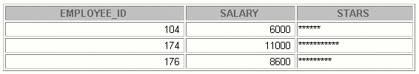
Practice 4 (continued)
If you have time, c omplete the following exercises:
3. Create an EMP table that is a replica of the
EMPLOYEES table. You can do this by executing the
script lab04_3.sql .Addanewcolumn, STARS ,of VARCHAR2
data type and length of 50 to the EMP ta ble for storing asterisk (*).
4. Create a PL/SQL block that rewards an employee by appending an asterisk in the
STARS column for ever y $1000 of the employee’s salary. Save your PL/SQL block in a file called
p4q4.sql by clicking on the Save Script button. Remember to save the script with a.sql
extension.
a. Use the DEFINE command to provide the employee ID. Pass the value to the PL/SQL
block through a iSQL*Plus substitution variable.
DEFINE p_empno=104
b. Init ialize a v_asterisk variable t hat contains a NULL.
c. Append an asterisk to the string for every $1000 of the salary amount. For example, if
the employee has a salary amount of $8000, the string of asterisks should contain eight
asterisks. If the employee has a salary amount of $12500, the string of asterisks should
contain 13 ast erisks.
d. Update the STARS column for the employee wit h the string of asterisks.
e. Commit.
f. Test the block for the following values:
DEFINE p_empno=174
DEFINE p_empno=176
g. Display the rows from the EMP table to verify whether your PL/SQL block has executed
successfully.
Note:
SET VERIFY OFF
in the PL/SQL block

